

**School of Computer Science and Engineering**

**SC2006 Software Engineering**

**Lab Group A26**

**Software Requirement Specification**

For

**TrainTogether**

Version 5.3 approved

**Prepared By:**

Lee Yen Foong Ernest (U2122511A)

Low Zhan Long (U2120919K)

Solomon Duke Tneo Yruan Rui (U2122205J)

Tey Li Zhang Edmund (U2121492J)

Wan Kai Jie (U2120427H)

14 April 2023

**Table of Contents**

**1.0** **Introduction** 1

1.1 Purpose 1

1.2 Document Conventions 1

1.3 Intended Audience 2

1.4 Product Scope 2

**2.0** **Overall Description** 3

2.1 Product Perspective 3

2.2 Product Functions 4

2.3 User Classes and Characteristics 5

2.4 Operating Environment 5

2.5 Design and Implementation Constraints 5

2.6 User Documentation 5

2.7 Assumptions and Dependencies 6

**3.0** **External Interface Requirements** 7

3.2 Hardware Interfaces 17

3.3 Software Interfaces 17

3.4 Communications Interfaces 19

**4.0** **Functional Requirements** 20

**5.0** **Other Nonfunctional Requirements** 22

5.1 Performance Requirements 22

5.2 Reliability Requirements 22

5.3 Safety Requirements 22

5.4 Security Requirements 23

**6.0** **Data Dictionary** 24

**7.0** **Other Requirements** 25

7.1 Installation 25

7.2 Running the App 25

**8.0** **Appendix** 26

8.1 Use Case Diagram 26

8.2 Use Case Description 27

8.3 Class Diagram 54

8.3.1 View and Routing Manager Class Diagram 55

8.3.2 Observer and Controllers Class Diagram 56

8.3.3 Models Class Diagram 57

8.4 Dialog Map 58

8.5 System Architecture 63

8.6 Sequence Diagram 64

8.7 Unit Testing 88

8.7.1 Black Box Testing 88

8.7.2 White Box Testing 96

# **Introduction**

## Purpose

The purpose of this SRS is to provide a detailed description of the requirements for the development of TrainTogether, a web application. The SRS outlines the functional and non-functional requirements of the web application including, use case models, class diagrams, sequence diagram, state machine diagram, user interface design, system architecture and other requirements. This document will also serve as a reference for the development team, stakeholders and clients, ensuring everyone involved in this project is clear and understands its objectives.

## Document Conventions

The following describes the standard and guidelines used in creating the TrainTogether Software Requirements Specification (SRS) document:

* + 1. Document Format

The SRS document will be created in Microsoft Word and saved as a .pdf file.

* + 1. Document Header

The SRS Document header will include: the document title (TrainTogether) and the document version number.

* + 1. Document Footer

The SRS Document Footer will include the page number and date of the document.

* + 1. Document Headings

The SRS Document Headings will be formatted at Times New Roman, font   
 size 18, bold.

* + 1. Document Subheadings

The SRS Document Subheadings will be formatted at Times New Romans,   
 font size 14, bold.

* + 1. Document Font

The font used throughout the SRS Document will be Times New Roman, size   
 12.

* + 1. Document List

For lists, bullet points will be used, while numberings will be used for steps and procedures.

* + 1. Document Tables

Tables will be used in this SRS Document to present data and information in a structured format.

* + 1. References

All references to external documents will be cited in the document and included in the reference list at the end of the document.

## Intended Audience

This SRS document is intended for all stakeholders involved in the making and   
 Implementation of the TrainTogether software system, including:

* + 1. Software Developers

To understand the constraints and technical details of the system

1.3.2 Project Managers

To ensure the project is on track with time, within budget, and according to client’s needs.

1.3.3 Quality Control Testers

To create test cases to ensure the system meets the functional, non-functional and specific requirements.

1.3.4 End Users

End users, including customers and backend users, will use this SRS as a reference to understand how the TrainTogether software works, its features and their responsibilities when using the software.

## Product Scope

TrainTogether is a web application and the ultimate fitness corner companion designed to help users achieve their fitness goals. TrainTogether can be used as a platform for users to find the nearest fitness corner and access to a wide range of pre-designed workout programs that are tailored to users’ fitness level, goals and the facilities at the fitness corner. At the same time, users can also use this web application to find restaurants that suit their fitness goals.

# **Overall Description**

## Product Perspective

TrainTogether is a web application that can be used across all browsers including but not limited to Google Chrome, Mozilla Firefox, Safari and Microsoft Edge. TrainTogether aims to provide a platform for users to search for nearby fitness corners and customise an exercise plan based on its location and facilities.

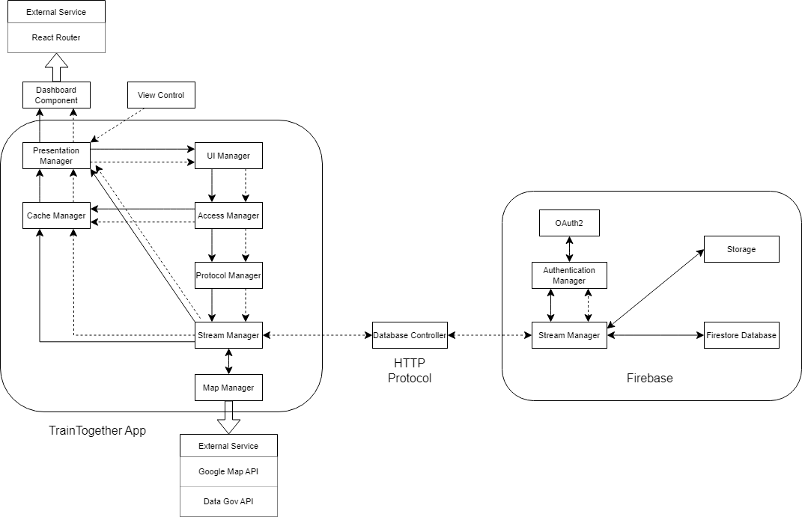

Diagram 1: System Client-Server Architecture Diagram of the TrainTogether Web Application

The TrainTogether application is a new, self-contained product which makes use of certain existing systems and Application Programming Interfaces (APIs) like Google Maps API and Data.gov API.

Shown on the left box above are all the systems in place to help the application run and interact with external services and systems.

The right hand side box shows the firebase systems which will assist our TrainTogether app with the fetching and storing of user information and transactions.

The database controller in the middle of the 2 boxes will act as the link between our application client and server database, with the use of HTTP Protocol.

## Product Functions

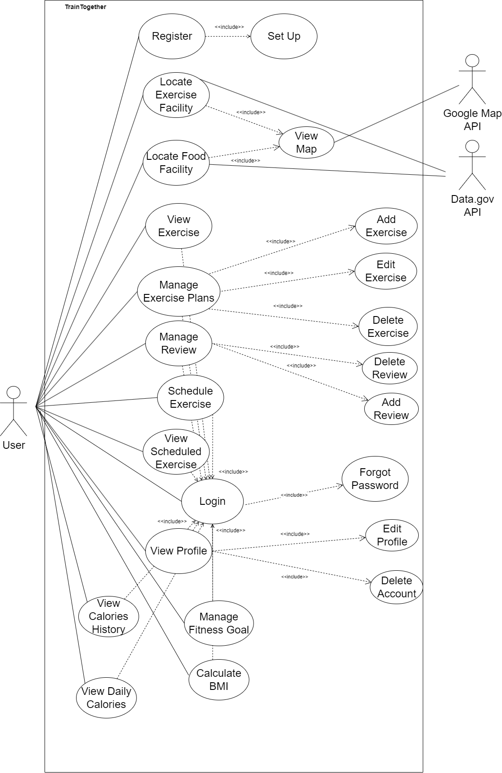

The TrainTogether must minimally be able to:

* Register users with a new account
* Allow users to login to their account with a unique identifier for account and password
* Allow users to locate exercise facilities (fitness corners) and food facilities
* Manage and edit exercise plans to suit their own needs
* Schedule exercises
* Edit Profile
* Manage and edit fitness goals based on their current fitness levels
* Review and rate exercises
* View Calories Burnt

## User Classes and Characteristics

There is only 1 main user class for TrainTogether, that is users who are interested in using our TrainTogether to create a workout plan at their nearby exercise facilities. The characteristics of our users are as followed:

* Users who are interested in fitness and exercise.
* They may have different levels of fitness experience, from beginners to advanced.
* They may have different fitness goals, such as weight loss, muscle building, or general fitness.
* They may have different preferences for workout types, durations, and intensities.
* They may want to track their progress and see improvements over time.
* They may be looking for efficient and effective workouts that can be easily incorporated into their daily routine.
* They may expect features such as quick and easy workout creation, saved workout templates, and personalised recommendations.

## Operating Environment

TrainTogether currently works on any web browser including Google Chrome, Mozilla Firefox as well as Microsoft Edge. It will also be using Firebase to store users’ data. Access to external APIs such as Data.gov API and Google Maps API is also required to provide additional information for our TrainTogether to work properly.

## Design and Implementation Constraints

TrainTogether currently only works on web browsers and it's only available in English. At the same time, the usage of Firebase has a few limitations including limited querying capabilities, data migration problems and it doesn’t work in countries that don’t allow Google. Nonetheless, TrainTogether can be converted easily from web browsing to mobile app since React supports such conversion.

The use of data.gov API may not be that updated hence the food facilities and exercise facilities may not be the most time-accurate information.

## User Documentation

A guide for how to use the TrainTogether Application will be made public for users to download. With the guide provided, it will increase the usability from the first interaction with the user as it is clear and easy to understand.

## Assumptions and Dependencies

* + 1. Availability of Internet Connection: It is assumed that users of the website application will have a stable and reliable internet connection to access the application and its features.
    2. Standard Web Browsers: It is assumed that users will access the website application using standard web browsers, such as Google Chrome, Mozilla Firefox, Safari, or Microsoft Edge, and the application will be designed and tested to be compatible with these browsers.
    3. Proper Input from Users: It is assumed that users will provide accurate and valid input while using the website application, such as selecting appropriate exercises and following recommended guidelines for creating their own workout plans.
    4. Authentication and Authorization: It is assumed that proper authentication and authorization mechanisms will be in place to ensure that only authorised users are able to access and modify their own workout plans.
    5. Third-Party APIs: The website application may have dependencies on third-party APIs for features such as exercise facilities data. Any changes or updates to these third-party APIs may impact the functionality of the website application.
    6. External Services: The website application may rely on external services, such as cloud storage, email notifications, or payment gateways, which may have their own dependencies and limitations that can affect the overall performance and availability of the application.

# **External Interface Requirements**

* 1. **User Interfaces**

Users can access the various user interfaces in TrainTogether as it is highly interlinked. Users will traverse through our applications based on their actions and interactions within our applications.

3.1.1 Register Page 1

The first page of our register page requires our users to enter their username, name, email address, password and confirm password. Upon selecting the register, users will be directed to Register Page 2. The username must be at least 6 characters long while the password must contain at least 8 characters, consisting of one number, one Uppercase, one Lowercase and one number and a special character.

Alternatively, if the user has an account, the user can choose to log in by clicking on the red “Log In” button and TrainTogether will direct them to login page.

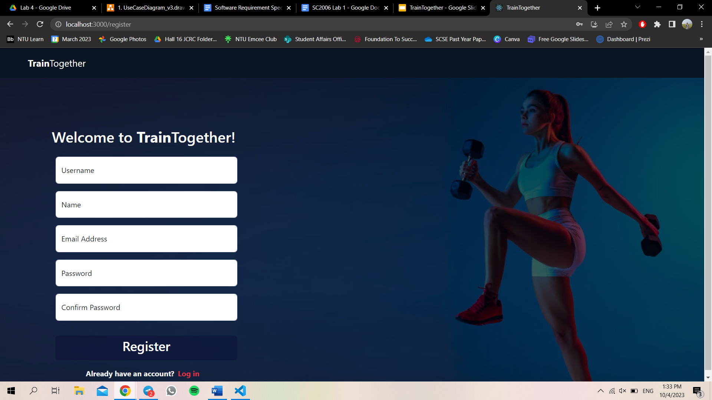

3.1.2 Register Page 2

The second page of the register page requires users to enter their date of birth with DD/MM/YYYY format, their phone number, height in cm, weight in kg, gender and a picture for their profile picture. After including all of their details, users can select Complete Setup and will be brought to our main landing page which is the dashboard.

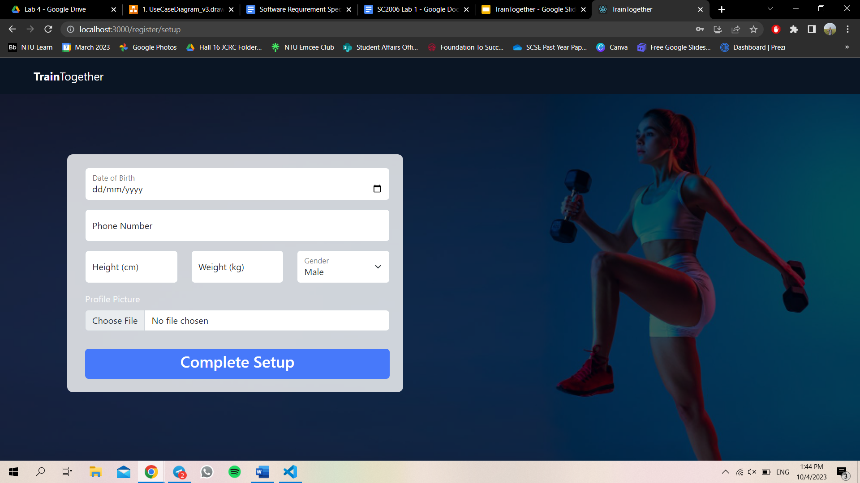

3.2.3 Login Page

The login page requires users to input their email address and password. Once the user has entered their email address and password, upon selecting login, TrainTogether will check if the email address and password provided is accurate, and direct the user to our main landing page, which is the dashboard. In this page, users who do not have an account can select sign up so that they will be directed to Register Page 1. Users who selected Forgot Password will be directed to the Forgot Password page.

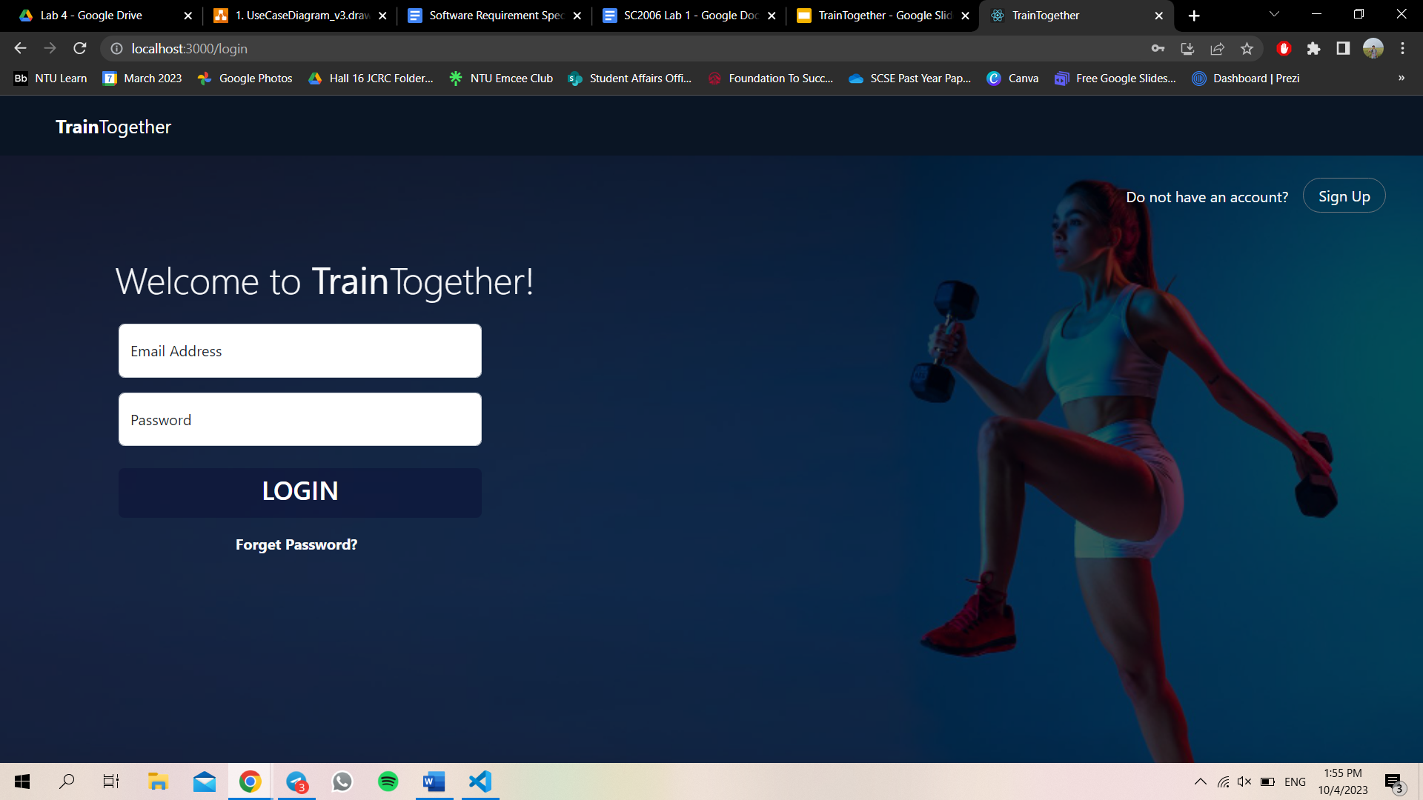

3.1.4 Forgot Password Page

At the Forgot Password Page, users are required to input their email address so that a link will be sent to the user to change his/her password.

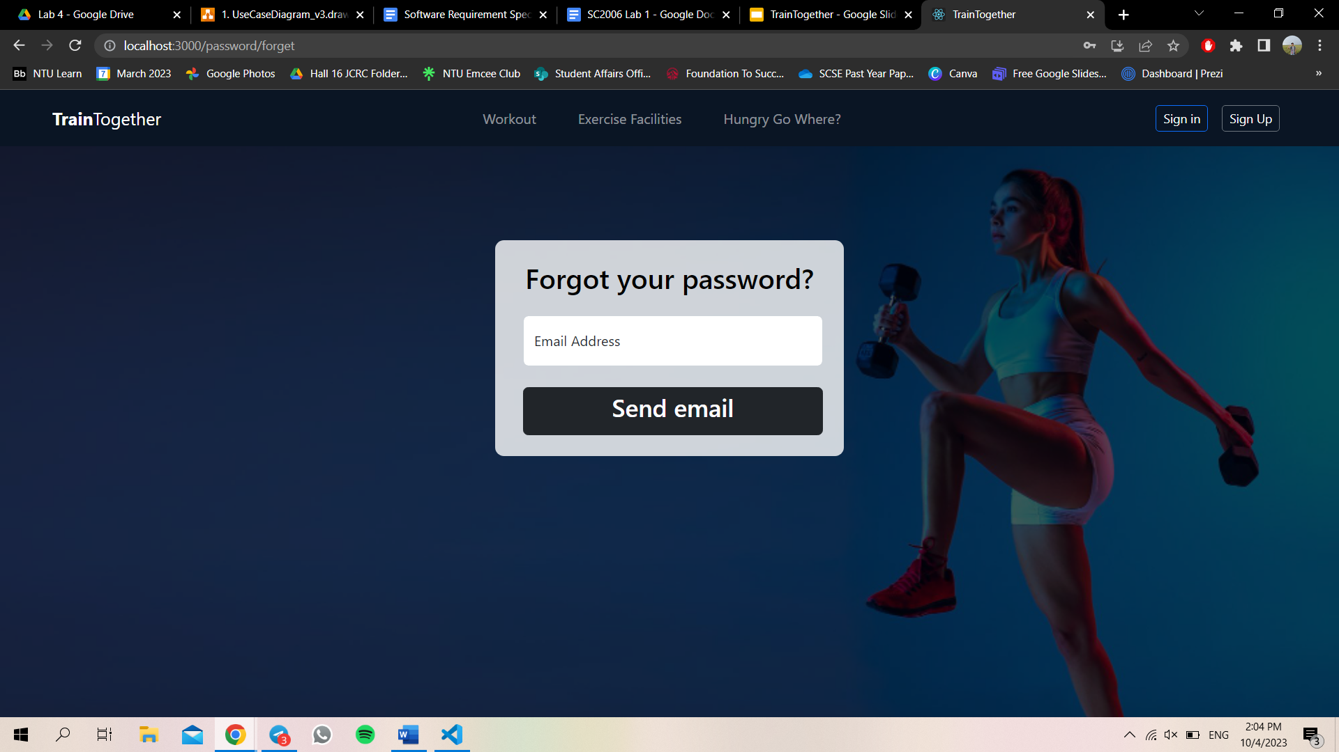

3.1.5 Dashboard Page

The Dashboard Page displays the calories burnt by the user for the day, located under “calories burnt”, a bar chart showing the calories burnt on a daily basis, located under “daily calories”, a BMI Calculator and Fitness Goals. Users can input their height and weight to calculate their Body Mass Index. Besides, users will be directed to the Fitness Goals page upon selecting the “plus icon” located beside Fitness Goals.

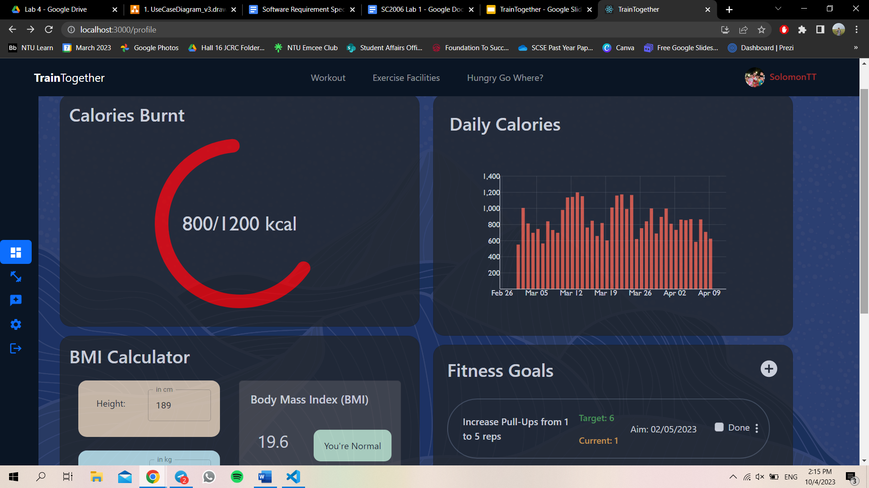

3.1.6 Fitness Goals Page

At the Fitness Goal page, user has to name the goal that user desires to achieve, eg: Push up,

Target value and current value in numeric, and a deadline for the goal. Once the user has entered the required details, the user can select submit.

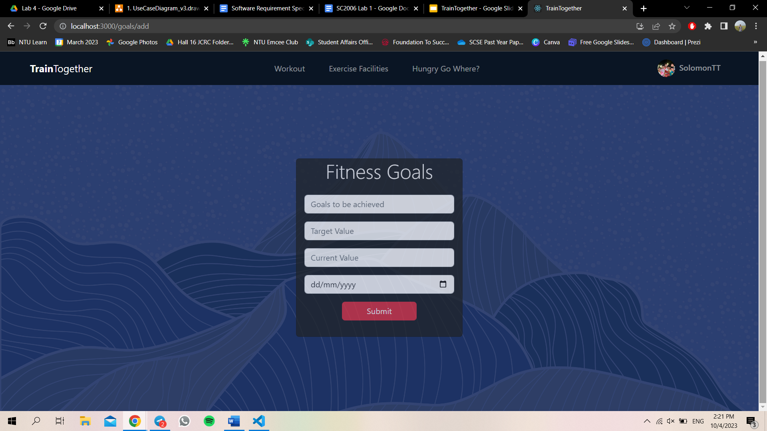

3.1.7 User Schedule Exercises Page

Selecting the dumbbell icon on the left sidebar of the dashboard page will direct users to the User Scheduled Exercises Page. In the User Schedule Exercises Page, users can see all of the scheduled exercise plans. Each scheduled exercise plan will show the name of the exercise plan, date and time. The three dots provide users the option to edit or delete the scheduled exercise plan.

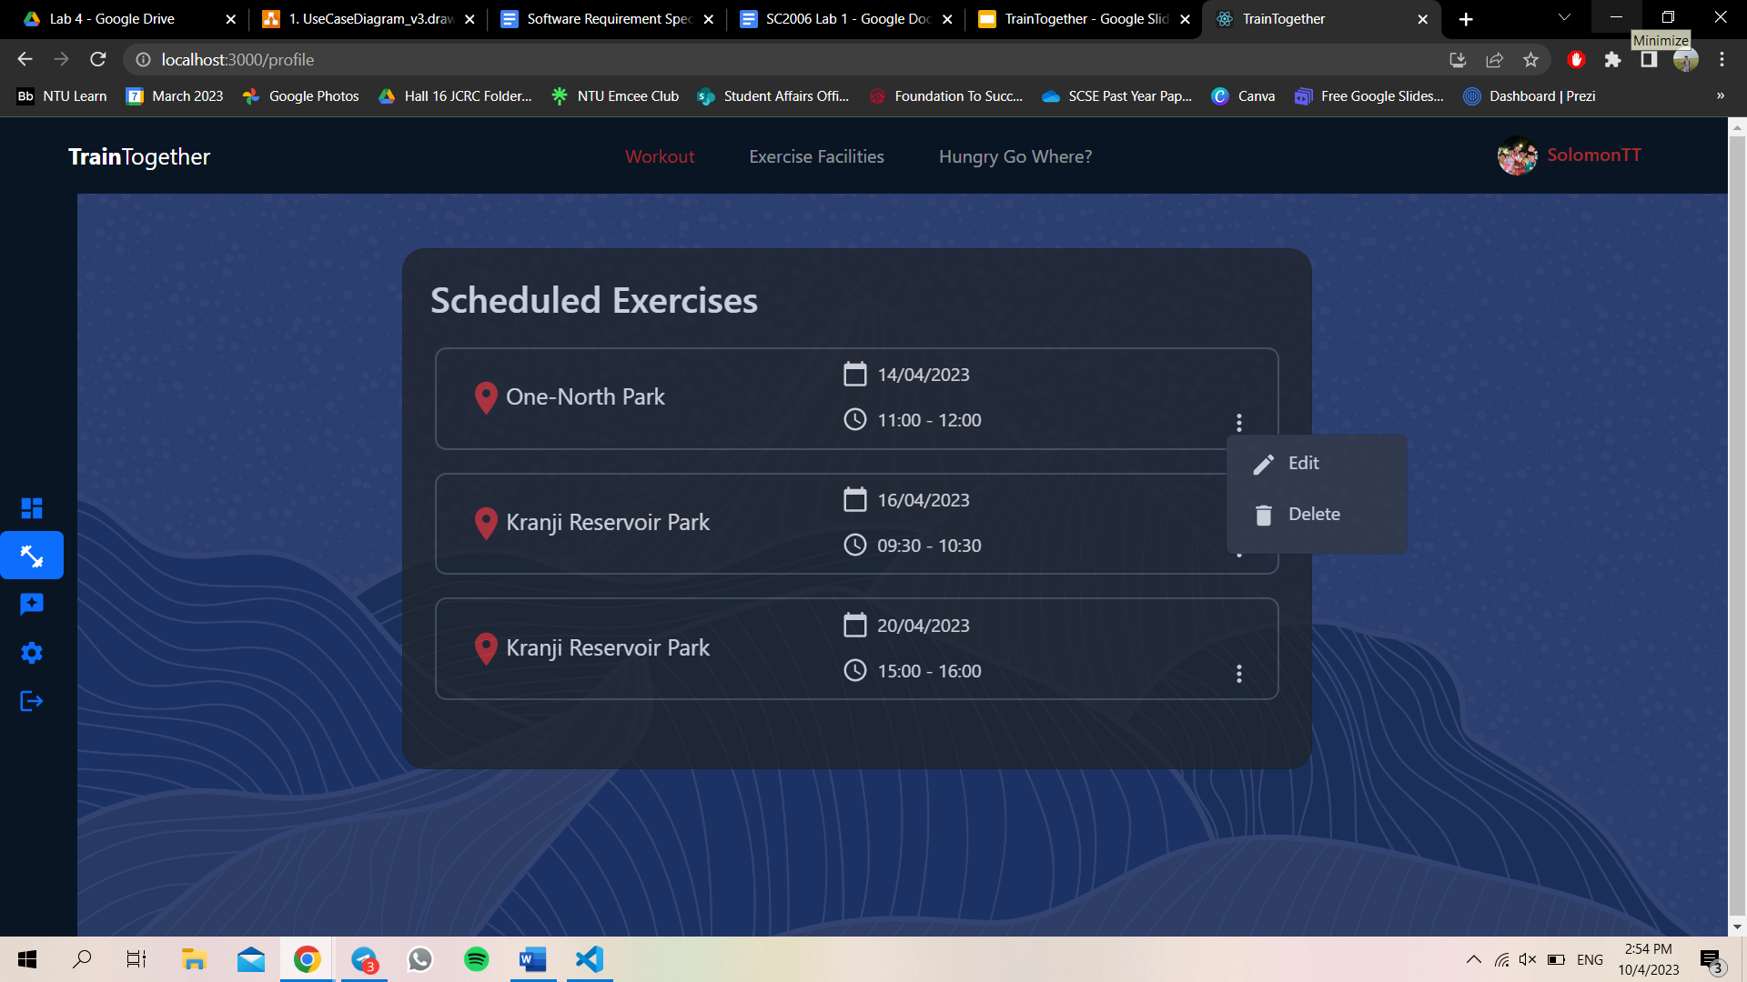

3.1.8 User Review Page

Selecting the chat box icon on the left sidebar of the dashboard will direct users to the user review page. Here, users can see all of the user's past reviews. Users can delete their reviews by selecting the “rubbish icon”.

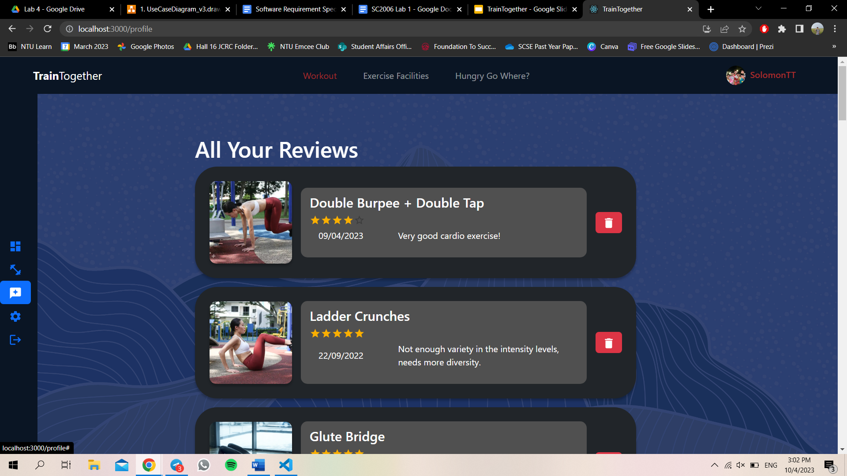

3.1.9.1 Settings - Account Page

Users will be directed to the settings page upon selecting the gear icon on the left sidebar of the dashboard. Users can choose to rename their username, update mobile number and email address at this page. Once the user is done with the editing, the user just has to click Done.

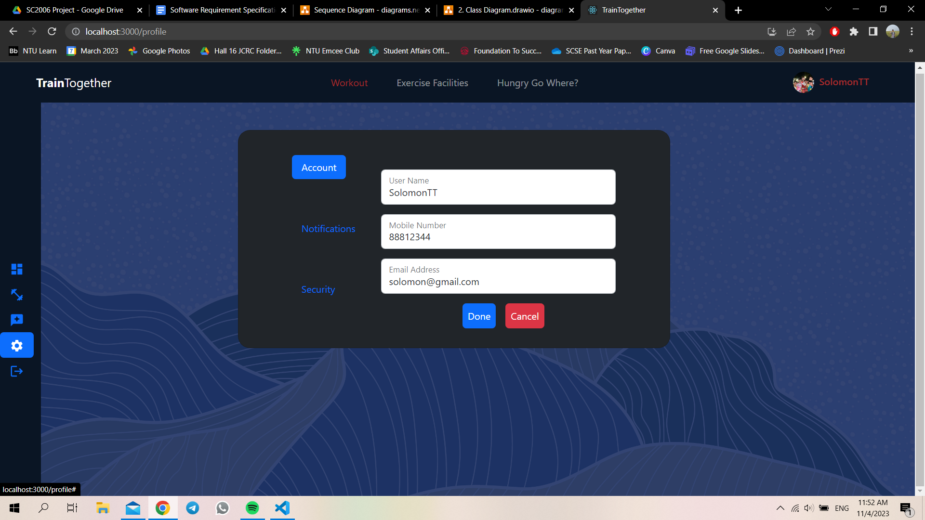

3.1.9.2 Settings - Security Page

Users have to enter their current password before entering their new password. At this page, users can choose to delete their account by selecting delete account.

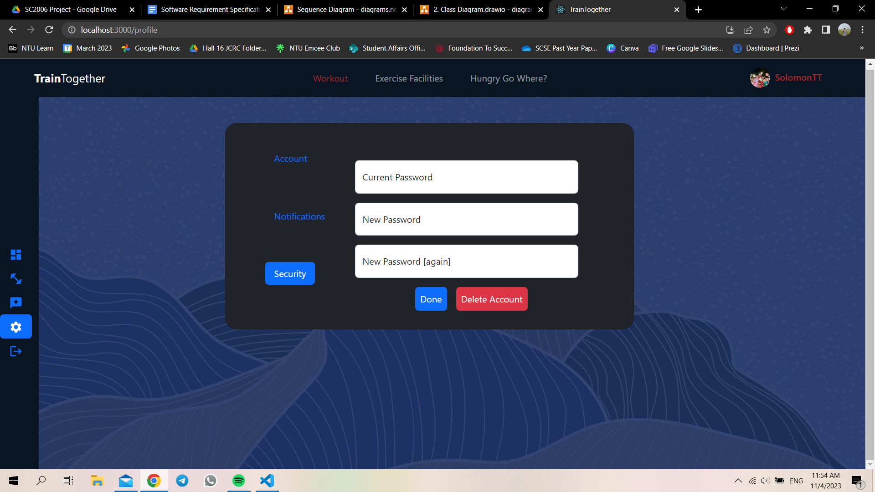

3.1.10.1 Workout Page - Exercise Plans

Users will be directed to the Workout Page upon selecting Workout at the top tab. At this page, there is a “Add Exercise Plan” option or “Schedule Exercise” option. Users will be directed to the add exercise plan page upon clicking on the “Add Exercise Plan” icon whereas users will be directed to the Schedule Exercise page upon clicking on the “Schedule Exercise” icon. The list of Exercise plans will also be shown here in a carousel manner.

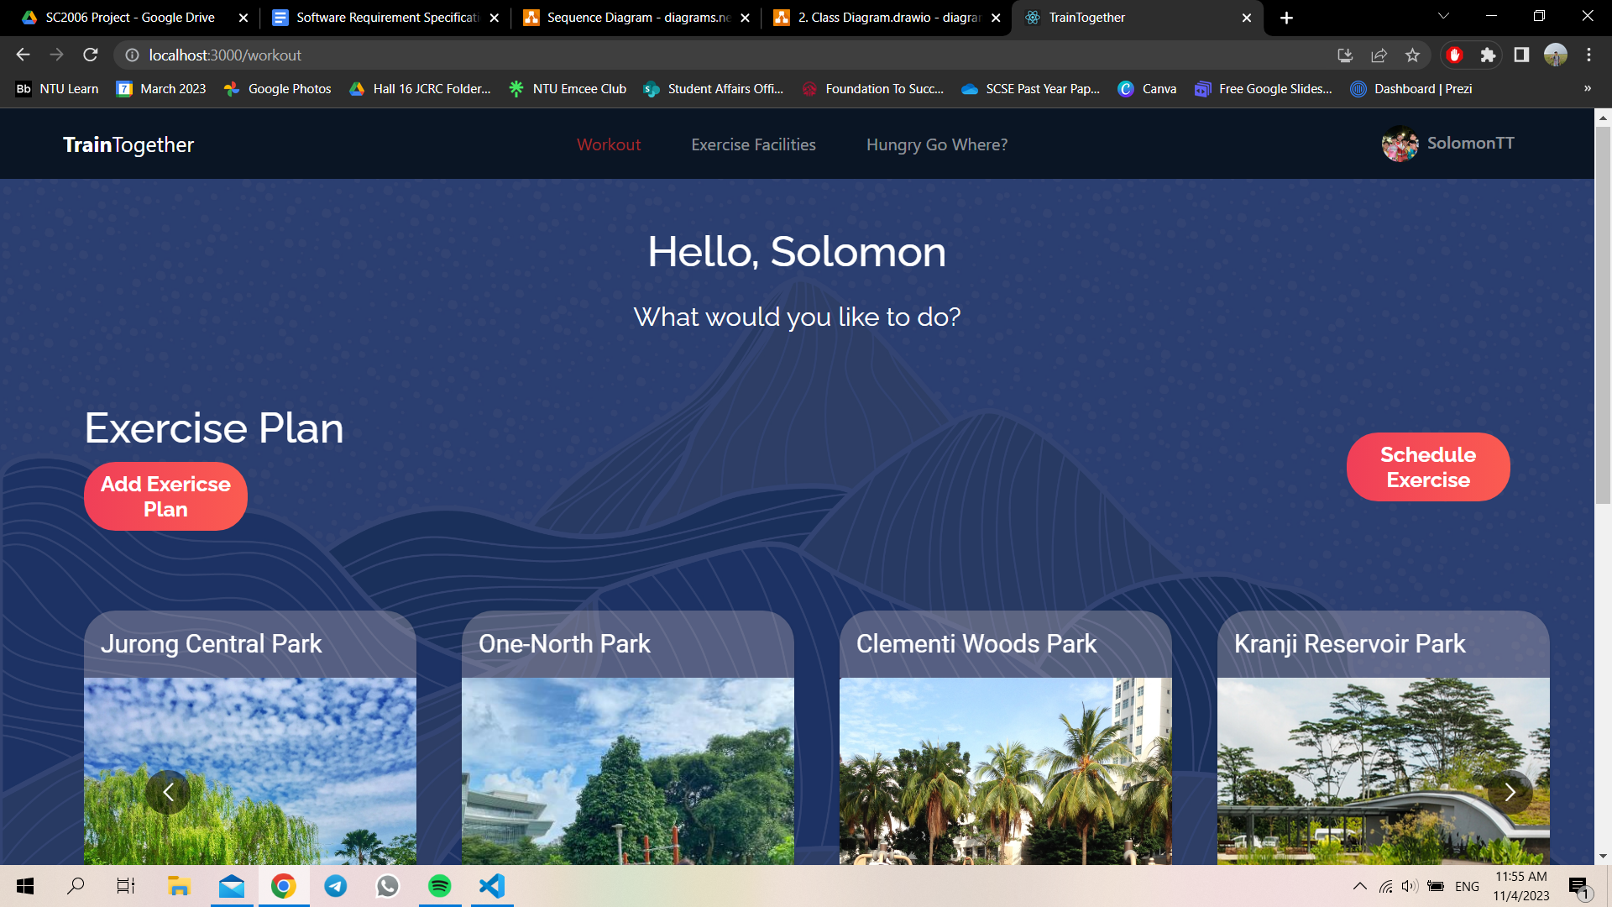

3.1.10.2 Workout Page - Exercise

Users will be directed to the exercise portion when they scroll down in the Workout Page. The list of exercises will also be shown here in a carousel manner, sorted according to exercise groups such as arms, back, cardio and core.

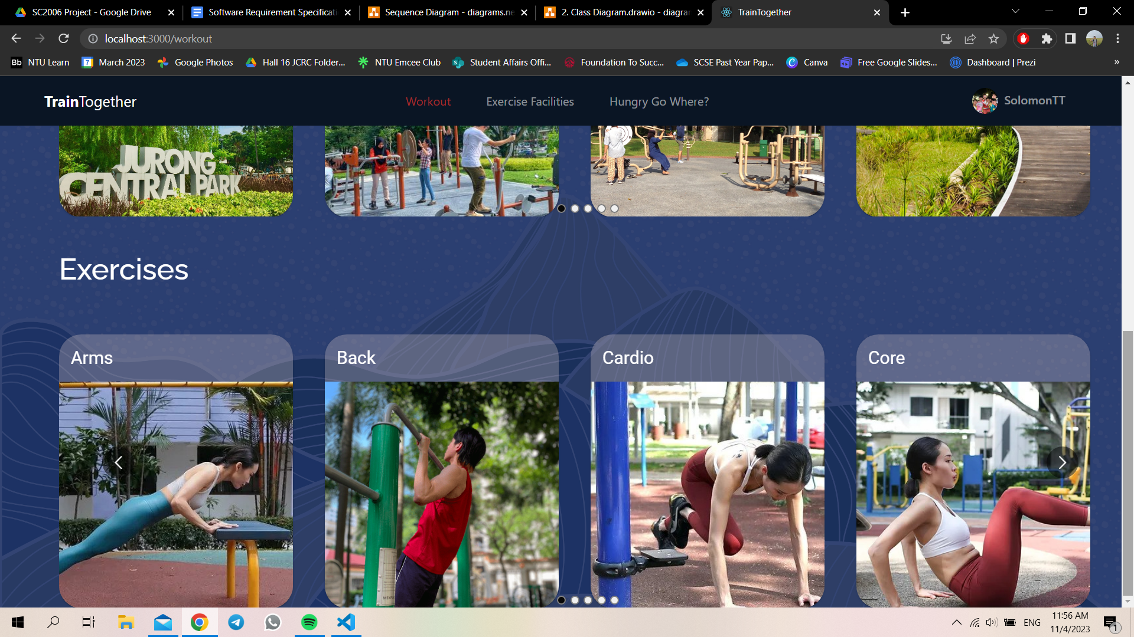

3.1.11 - Exercise Plan Page

When a user selects an exercise plan, they will be directed to the exercise plans page. Here, the type of exercises tagged to the exercise plan, including its reps, sets, rests and calories burned will be shown here.

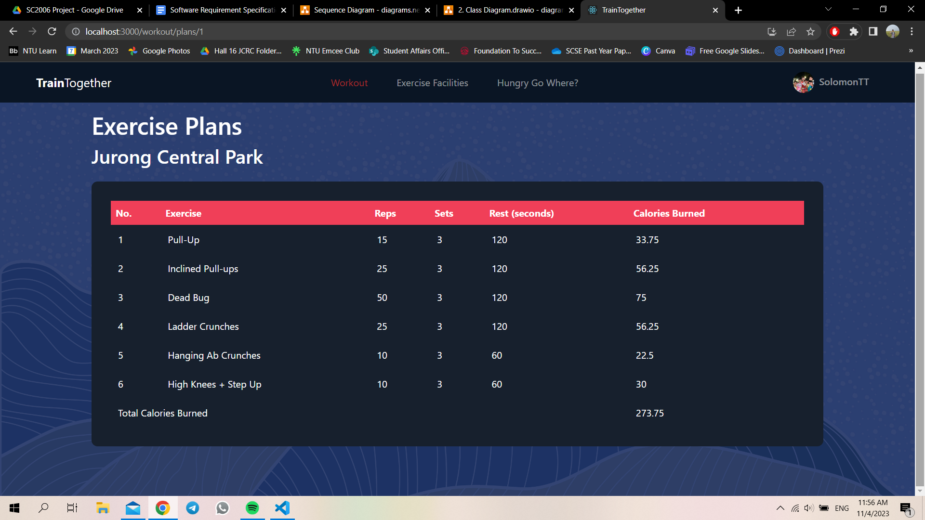

3.1.12 - Exercise Page

When a user selects an exercise from the exercise carousel, they will be directed to the exercise page. Here, the instructions and remarks of the exercise will be shown here. The average rating of the exercise out of 5 stars will also be shown here. There is also a review button that will direct users to the review page upon clicking.

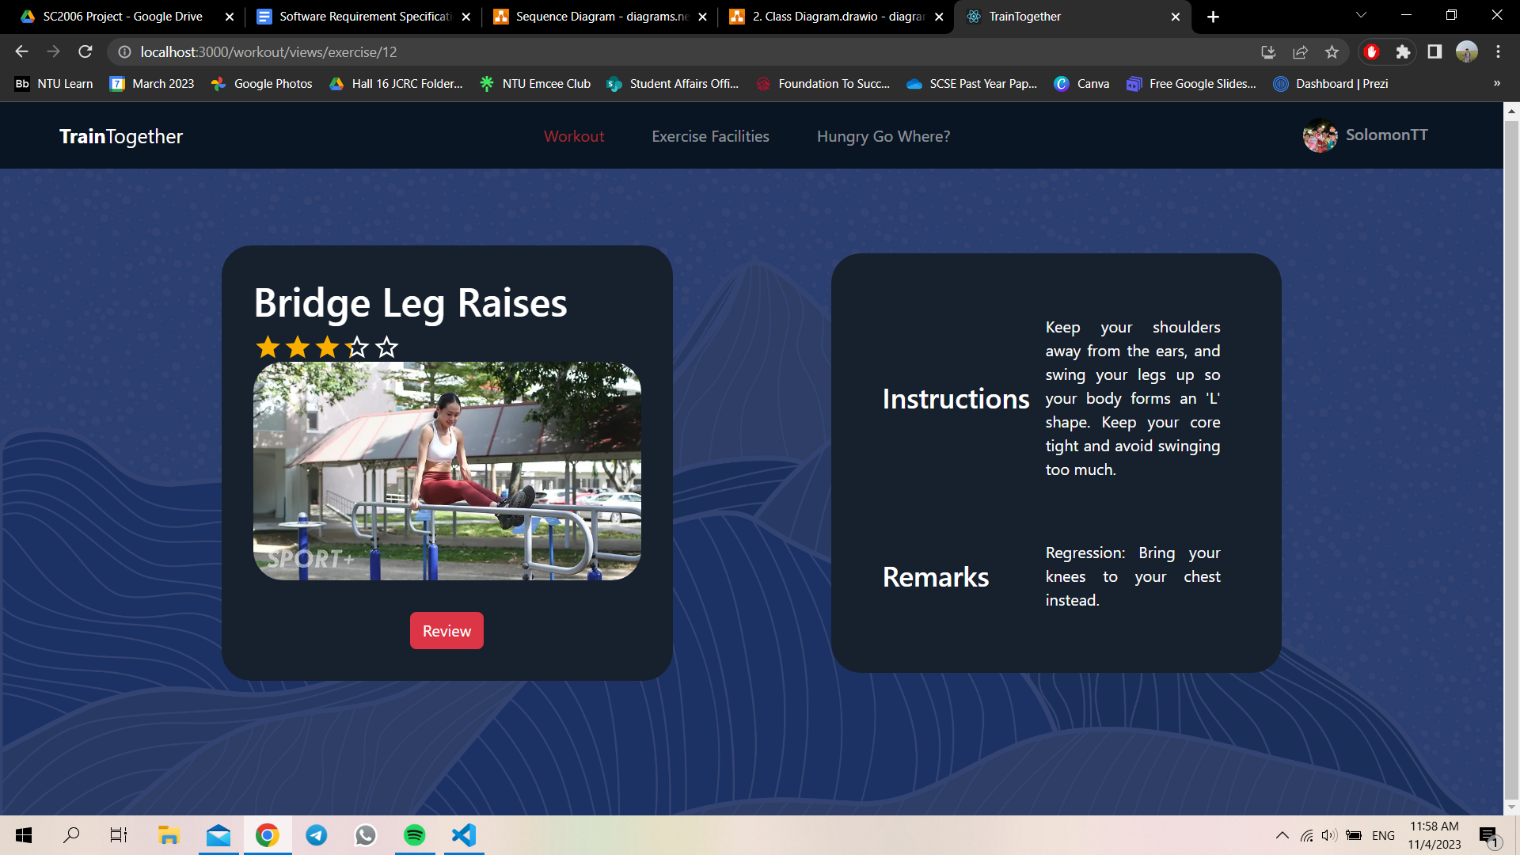

3.1.13 - Review Page

At the review page, users can see ratings and reviews made by other users. Users will be directed to the Add Review Page upon selecting the “Add Review” button.

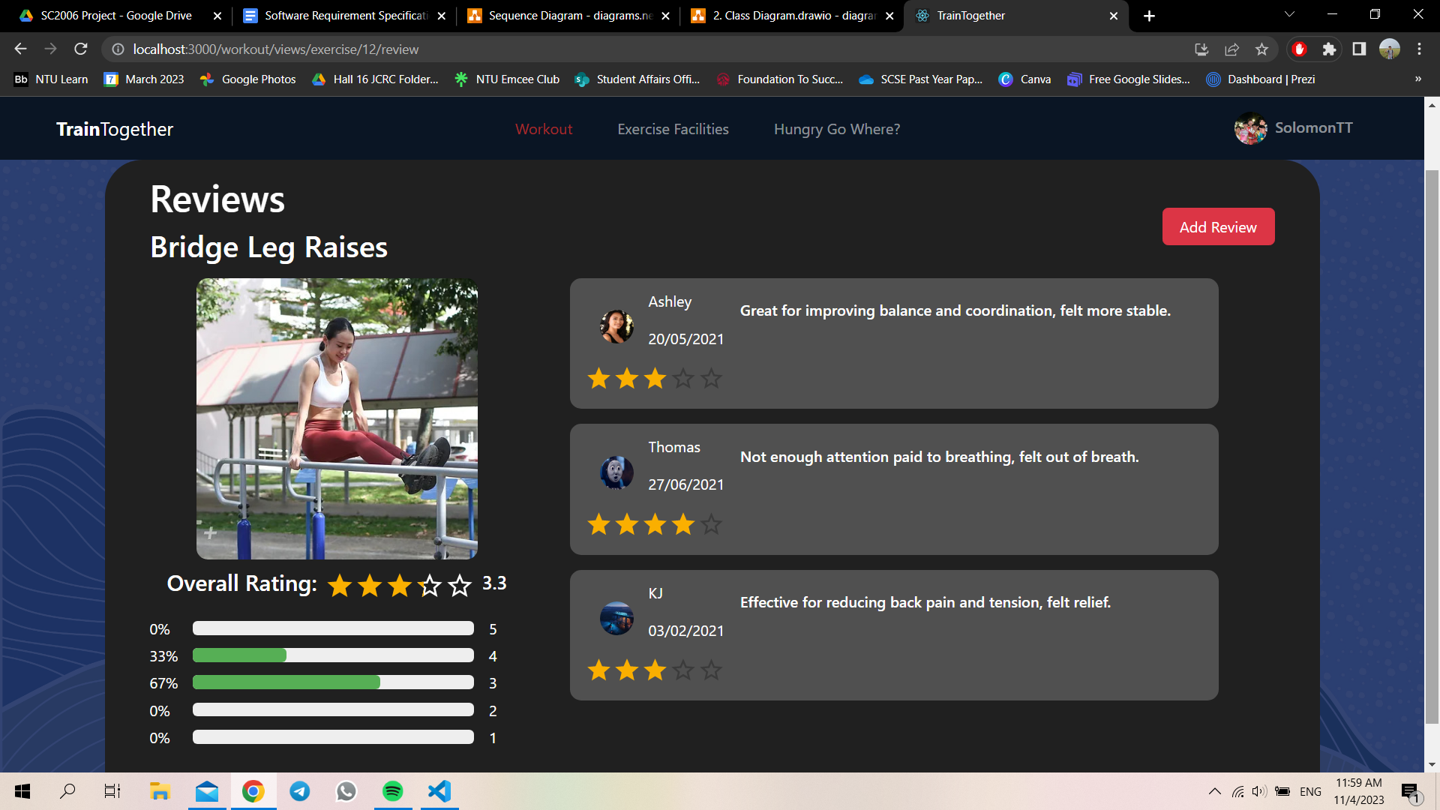

3.1.14 - Add Review Page

At the Add Review Page, users are to give their ratings for the exercise using 5 stars. Users can also include comments and reviews for the exercise. Once the user is done, the user can select submit and their reviews will be stored in the database.

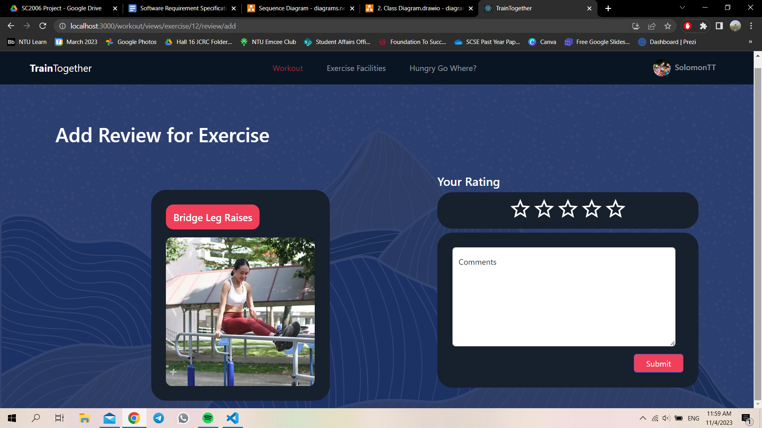

3.1.15 - Schedule Exercise

The schedule exercise page consists of a calendar, start time, end time input bar and a list of exercise plans. Users can schedule their exercise plans on this page. Users must include the date, start and end time of the exercise plan before clicking the submit button.

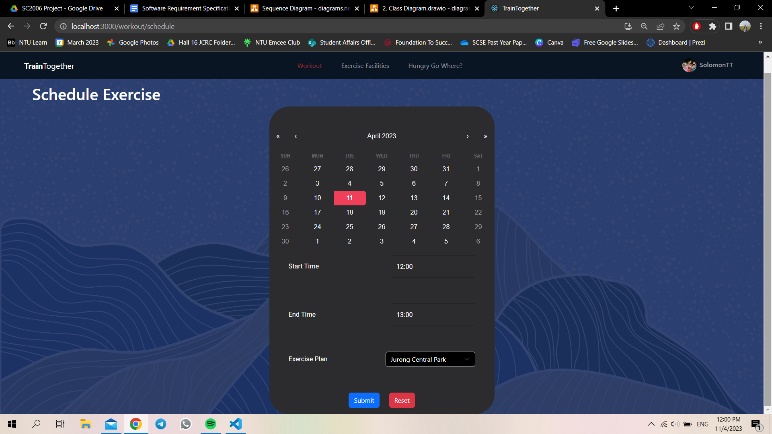

3.1.16 - Add Exercise Plan

Users can create their own customised set of exercise plans on this page. To do so, users have to name the exercise plan, add exercises from the list of exercises sorted based on their exercise group.

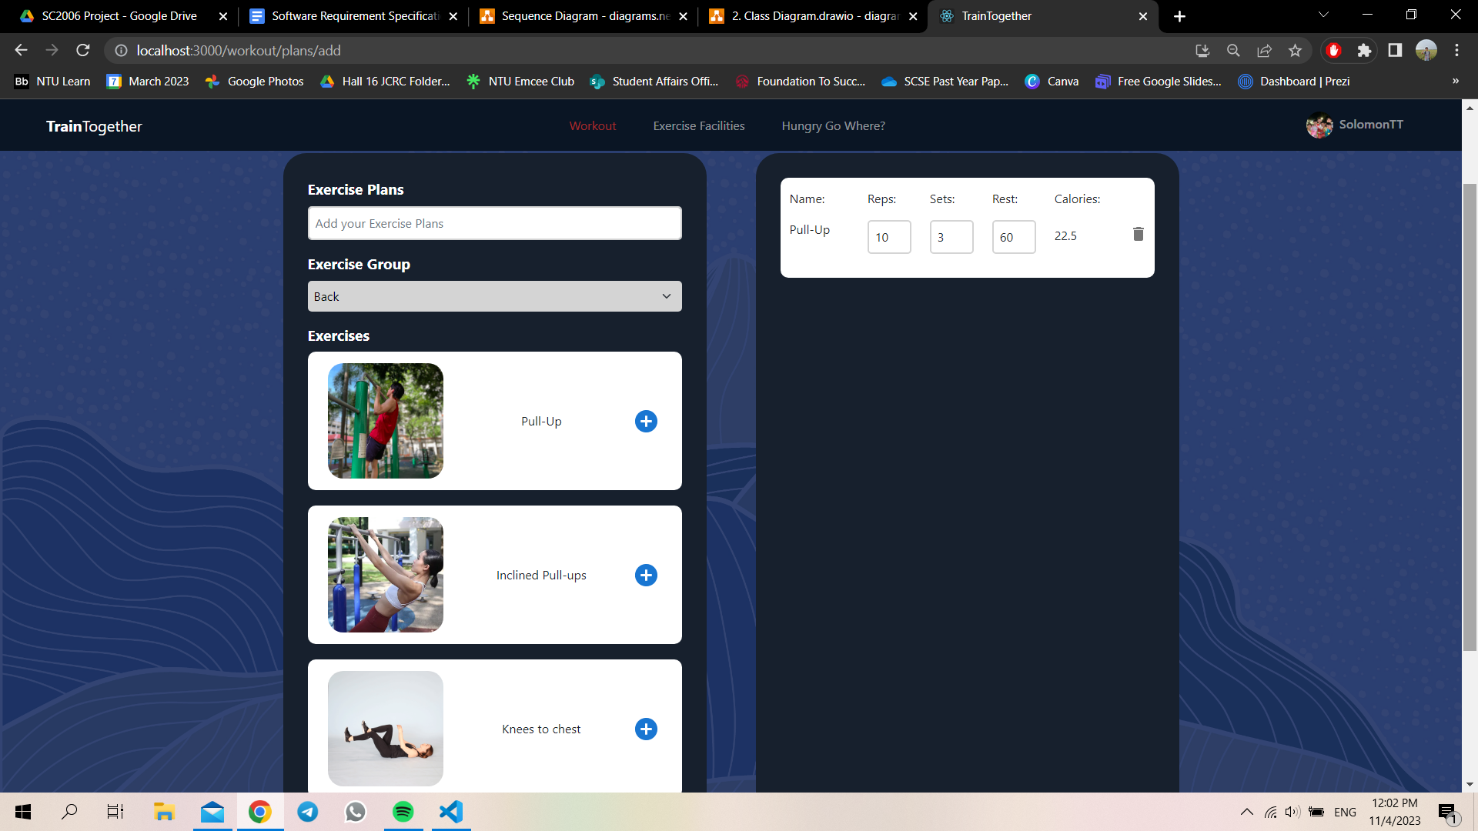

3.1.17 - Exercise Facilities

The exercise facilities page is TrainTogether’s main landing page. It consists of a Google Map and the details of the fitness park. Users can make use of the search bar in the Google Map to search for the nearest fitness corner. Under the park details, the address, postal code, opening hours and website of the park will be displayed here.

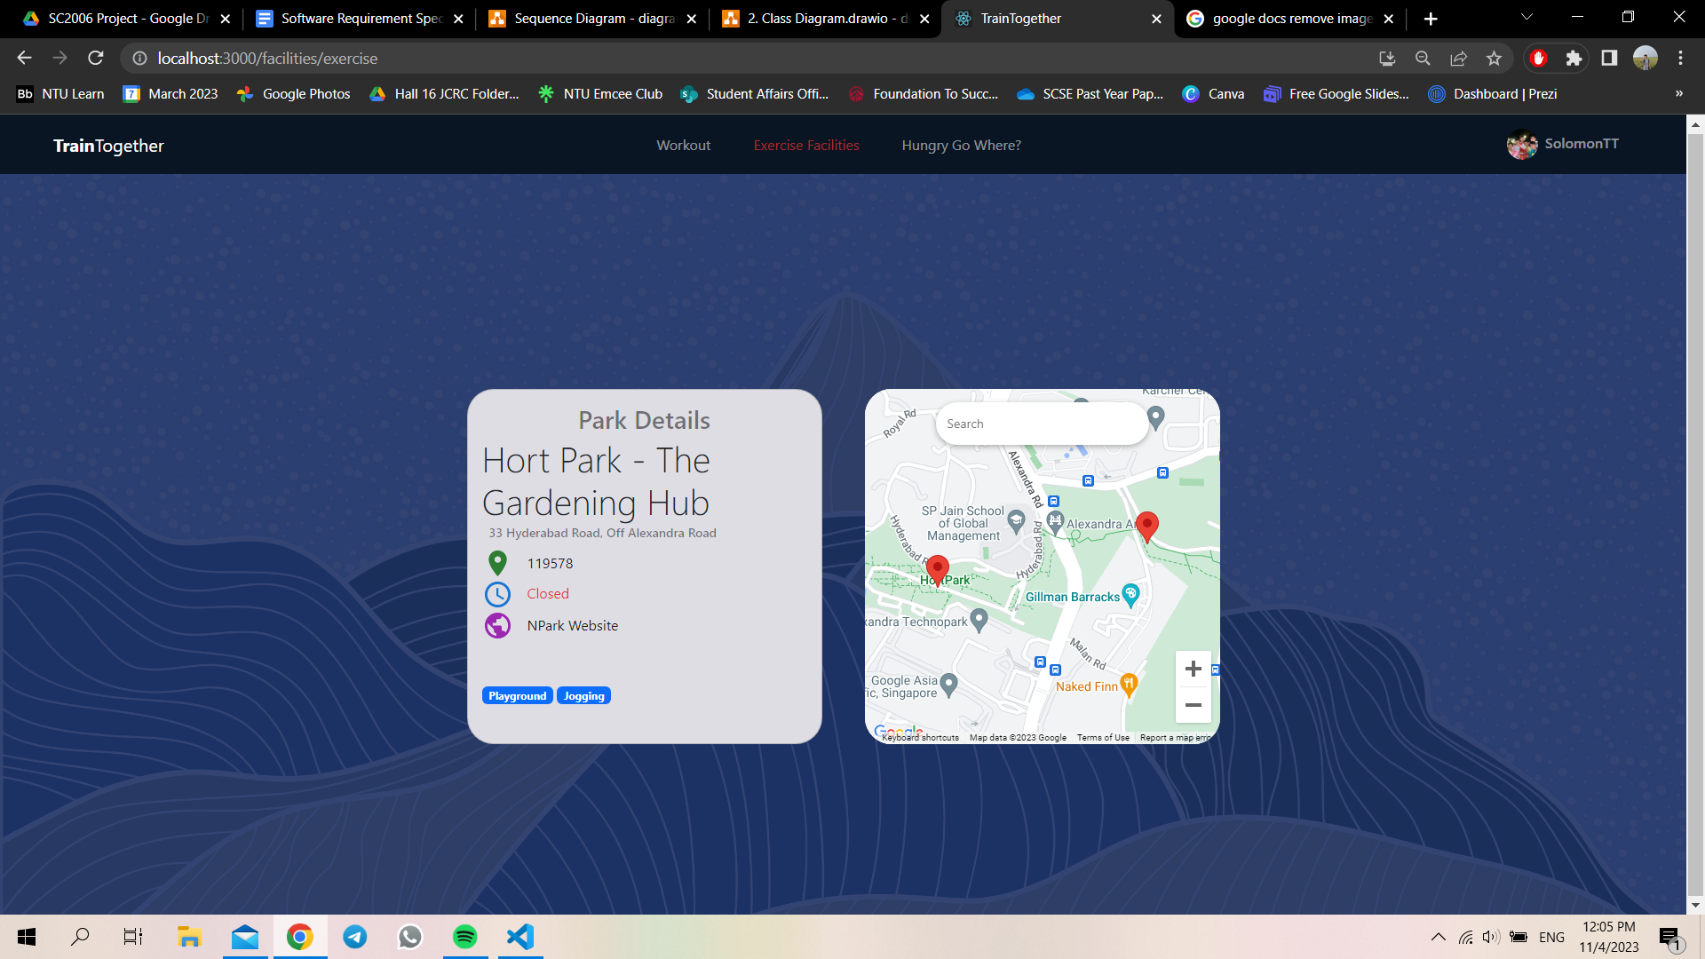

3.1.18 Hungry Go Where

The Hungry Go Where page consists of a Google Map and the details of the food facility. Users can make use of the search bar in the Google Map to search for the nearest healthy food facility. At the same time, users can choose to filter the food facility based on its Health Category, Food Type, Dining Guidelines, Venue and Regions. Under the food facilities details, the location address, category, type and mode will be displayed.

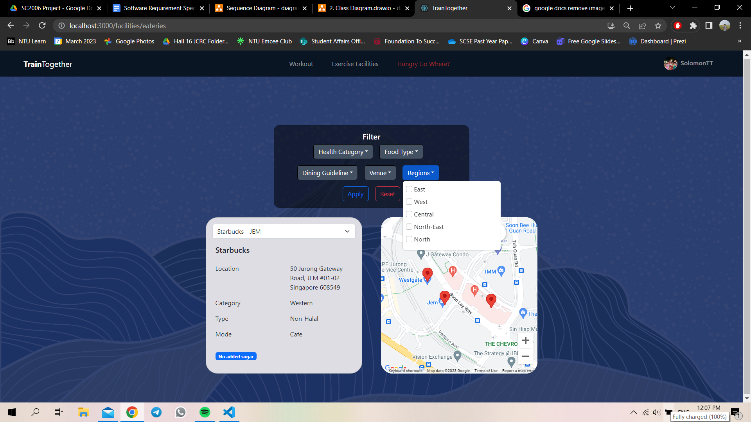

## Hardware Interfaces

TrainTogether is a web-based application that can be accessed using the web browser by desktop, laptops, tablets and phones.

To use the location-based feature of TrainTogether, the device must have access to GPS sensors and grant access to TrainTogether to use it. This allows TrainTogether to communicate with the GPS sensor in the device to provide the user’s current location on Google Maps.

TrainTogether also must communicate with network components, like routers and servers to establish a connection to the internet to receive and transmit data. TrainTogether uses standard internet protocols, such as HTTP, TCP/IP and HTTPS to communicate with the network components.

## Software Interfaces

TrainTogether is built using React and Firebase. React is a JavaScript library for building user interfaces. Firebase provides the backend for the application, which includes user authentication, storage, and real-time database. TrainTogether also integrates with external APIs such as Google Maps API and Data Gov API.

For React, we have the following third-party dependencies and their version numbers:

| **Dependency** | **Version** | **Description** |
| --- | --- | --- |
| @emotion/react | ^11.10.6 | CSS-in-JS library for React |
| @emotion/styled | ^11.10.6 | CSS-in-JS library for React |
| @mui/icons-material | ^5.11.11 | Material icons for MUI |
| @mui/material | ^5.11.12 | React components for MUI |
| @mui/x-date-pickers | ^6.0.0 | Date picker components for MUI |
| @react-google-maps/api | ^2.18.1 | React components for Google Maps API |
| @syncfusion/ej2-react-lineargauge | ^20.4.48 | React components for Syncfusion's linear gauge |
| @testing-library/jest-dom | ^5.16.5 | Custom Jest matchers for testing DOM nodes |
| @testing-library/react | ^13.4.0 | Testing utilities for React |
| @testing-library/user-event | ^13.5.0 | Testing utilities for user events in React components |
| bootstrap | ^5.2.3 | CSS and JavaScript framework for building responsive, mobile-first websites |
| date-fns | ^2.29.3 | Date utility library for JavaScript |
| dayjs | ^1.11.7 | Date utility library for JavaScript |
| firebase | ^9.18.0 | Firebase SDK for building web and mobile applications |
| formik | ^2.2.9 | Library for building forms in React |
| prop-types | ^15.8.1 | Runtime type checking for React props |
| react | ^18.2.0 | JavaScript library for building user interfaces |
| react-bootstrap | ^2.7.0 | Bootstrap components built with React |
| react-calendar | ^4.0.0 | Calendar component for React |
| react-dom | ^18.2.0 | Entry point for React DOM rendering |
| react-hot-toast | ^2.4.0 | Toast notification library for React |
| react-multi-carousel | ^2.8.2 | Carousel component for React |
| react-router-bootstrap | ^0.26.2 | React Router components for Bootstrap |
| react-router-dom | ^6.8.0 | Declarative routing for React |
| react-scripts | ^5.0.1 | Configuration and scripts for Create React App |
| victory | ^36.6.8 | Charting library for React |
| web-vitals | ^2.1.4 | Library for measuring web vital metrics |
| yup | ^0.32.11 | Library for schema validation |

The list of dependencies could also be found in package.json.

## Communications Interfaces

TrainTogether requires an internet connection and must be able to communicate with components such as routers and servers to connect to the Firebase backend. The application communicates with Firebase server via REST APIs over HTTPs protocols. Data transfer rate will be determined by the user’s internet speed. The Firebase server provides data synchronisation, ensuring that the app always displays the most up-to-date information. Communication security is also provided by Firebase, which uses SSL/TLS encryption to protect data communication.

TrainTogether also requires communication with external APIs such as Google Maps API and Data.gov API.

# **Functional Requirements**

* 1. Users must be able to register for a new account.
     1. Users must provide the following details: username, name, email, mobile number, password, height, weight and date of birth.
        1. TrainTogether must prompt the user to change username if the username has already been taken.
        2. TrainTogether must prompt the user to change username if the username does not contain at least 6 characters.
        3. TrainTogether must prompt the user to change password if the password didn’t adhere to the system’s requirement: at least 8 characters, at least 1 special character and letters in mixed cases.
        4. TrainTogether must prompt the user to change the email if the email does not contain the “@” character.
        5. Users may choose to upload a picture to be used as their profile picture.
        6. TrainTogether must create a new account for the user if all the

requirements are fulfilled.

* 1. Users must be able to login with their valid email and password.
     1. TrainTogether must be able to validate the user's username and

Password.

* + 1. TrainTogether must direct the user to the main landing page after

validating the user's credentials.

* 1. Users must be able to query for exercise facilities based on the location.
     1. Users must be able to view a map of nearby exercise facilities such as fitness corners.
     2. Users must be able to view the details of the exercise facilities.
        1. The details of the exercise facilities must include details such as its address, postal code, opening hours and website.
  2. Users must be able to query for food facilities based on the location.
     1. Users must be able to filter the food facilities based on health category.
        1. The health category includes lower in sugar, higher in wholegrains, lower in calories, no added sugar, source of dietary fibre, eat 2+2 servings of fruits, vegetables daily.
     2. Users must be able to filter food facilities by food type.
        1. The food type must include drinks, western, desserts, snack and kuehs, bubble tea, Chinese, fast food, Malay, Thai, cut fruits, Japanese, Korean, local flavours, Fusion, Indian.
     3. Users must be able to filter food facilities by dining guideline, which is either Halal or non-halal.
     4. Users must be able to filter food facilities by Venue
        1. The venue includes hawker centre, bakery, cafe, kiosk, restaurant, fast food, coffee shop, dessert, F&B on digital platform(s).
     5. Users must be able to filter food facilities by regions
        1. The regions must include East, West, Central, North-East, North
  3. Users must be able to browse exercises.
     1. Users must be able to view detailed instructions on how to perform the exercise.
     2. Users must be able to view the remarks, average ratings for each exercise.
  4. Users must be able to manage their exercise plan.
     1. Users must be able to create new exercise plans.
     2. Users must be able to add new exercises to their exercise plan.
     3. Users must be able to remove exercises from their exercise plan.
     4. Users must be able to delete their exercise plans.
  5. Users must be able to manage reviews for each exercise.
     1. Users must be able to add reviews by leaving a comment for the exercise.
        1. Users must be able to rate the exercise using out of 5 stars.
     2. Users must be able to view all reviews posted by other users of the exercise, including their own.
     3. Users must be able to delete their own reviews.
  6. Users must be able to schedule their exercise.
     1. Users must be able to schedule an exercise plan by selecting a time and date for that particular exercise.
     2. Users must be able to view all of their scheduled exercises.
     3. Users must be able to remove scheduled exercises.
  7. Users must be able to edit their profile.
     1. Users must be able to change their username, mobile number and email address.
     2. Users must be able to change their notification choice.
        1. Users must be able to change their notification choice for exercise reminders
        2. Users must be able to change their notification choice for email notification
     3. Users must be able to update their password.
        1. TrainTogether must prompt the user to enter the user’s current password before updating the password.
        2. Users must enter a password with at least 8 characters, 1 special character, 1 uppercase, 1 lowercase and 1 number.
        3. Users must be able to delete their account.
  8. Users must be able to manage their fitness goals.
     1. Users must be able to add their fitness goals.
        1. Users must clearly specify the goal to be achieved.
        2. TrainTogether must prompt the user to enter a numeric value for their fitness goals.
        3. Users must be able to select a date as a deadline for that particular fitness goal.
     2. Users must be able to edit fitness goals.
     3. Users must be able to delete fitness goals.
  9. Users must be able to calculate their Body Mass Index.
     1. TrainTogether must prompt the user to enter the user's height and weight to

calculate the user's body mass index.

* 1. Users must be able to view their past calories burnt in a bar chart format.
  2. Users will be able to view the amount of calories burnt for the day.

# **Other Non-functional Requirements**

## Performance Requirements

* + 1. TrainTogether must be compatible with the latest version of major web browsers (Chrome, Firefox, Safari, Edge)
    2. The design must have clear navigation toolbars and consistent designs for easy navigability.
    3. Response time of TrainTogether should be no longer than 3 seconds after user’s input.
    4. TrainTogether must be able to handle an increase in traffic by at least 100% without performance degradation.
    5. TrainTogether must be able to store at least 1 million records.

## Reliability Requirements

* + 1. TrainTogether must ensure that errors should not crash the application.
    2. TrainTogther must restart within 1 minute if it crashed.

## Safety Requirements

* + 1. TrainTogether must have clear and updated documentation for developers to understand and improve the app.
    2. TrainTogether needs to have error prevention functions.
       1. TrainTogether must route users to another page when an error occurs with clear concise error description.
       2. Error Pages should appear when users navigate into an invalid page.

## Security Requirements

* + 1. TrainTogether must ensure that every user is valid and has the correct permission to perform actions.
       1. TrainTogether must have OAuth2 Authentication verification before allowing the user access to certain actions.

# 

# **Data Dictionary**

| **Term** | **Definition** |
| --- | --- |
| Exercise | A physical activity that the user engages in to improve their fitness and health. |
| Exercise Plan | A collection of exercises that a user has created or added to their workout routine, including details on the repetitions, rest time, and sets for each exercise. |
| Exercise Facility | A fitness corner where users can engage in physical activity. |
| Scheduled Exercise | A time and exercise facility where the user schedule his exercise plan |
| Fitness Goal | A target that the user sets for themselves, such as a certain number of calories burned or a specific exercise to be completed. |
| Location | The location of the user and exercise facilities, as provided by the device's GPS or manually entered by the user. |
| Reviews | Reviews that are left by users, which can be both qualitative and quantitative, pertaining to the suggested exercises. |
| Food Facility | An eatery which is part of Health Promotion Board’s list of healthy eateries |

# **Other Requirements**

## Installation

* + 1. To install and run the app, you will need to have Node.js and npm installed on your computer. Node.js is a runtime environment that allows you to run JavaScript code outside of a browser. npm is a package manager that lets you install and manage dependencies for your project.
    2. To install Node.js and npm, you can follow the instructions on their official website: <https://nodejs.org/en/>.
    3. Once you have Node.js and npm installed, you need to install the node modules that are required for the app. These are the libraries and packages that provide various functionalities and features for the app.
    4. To install the node modules, you need to navigate to the project folder in your terminal and run the following command: npm install

## Running the App

* + 1. To run the app, you need to use the following command in your terminal: npm start
    2. This will start a local server and open the app in your default browser. You can also access the app by visiting http://localhost:3000 in your browser.

# **Appendix**

## Use Case Diagram

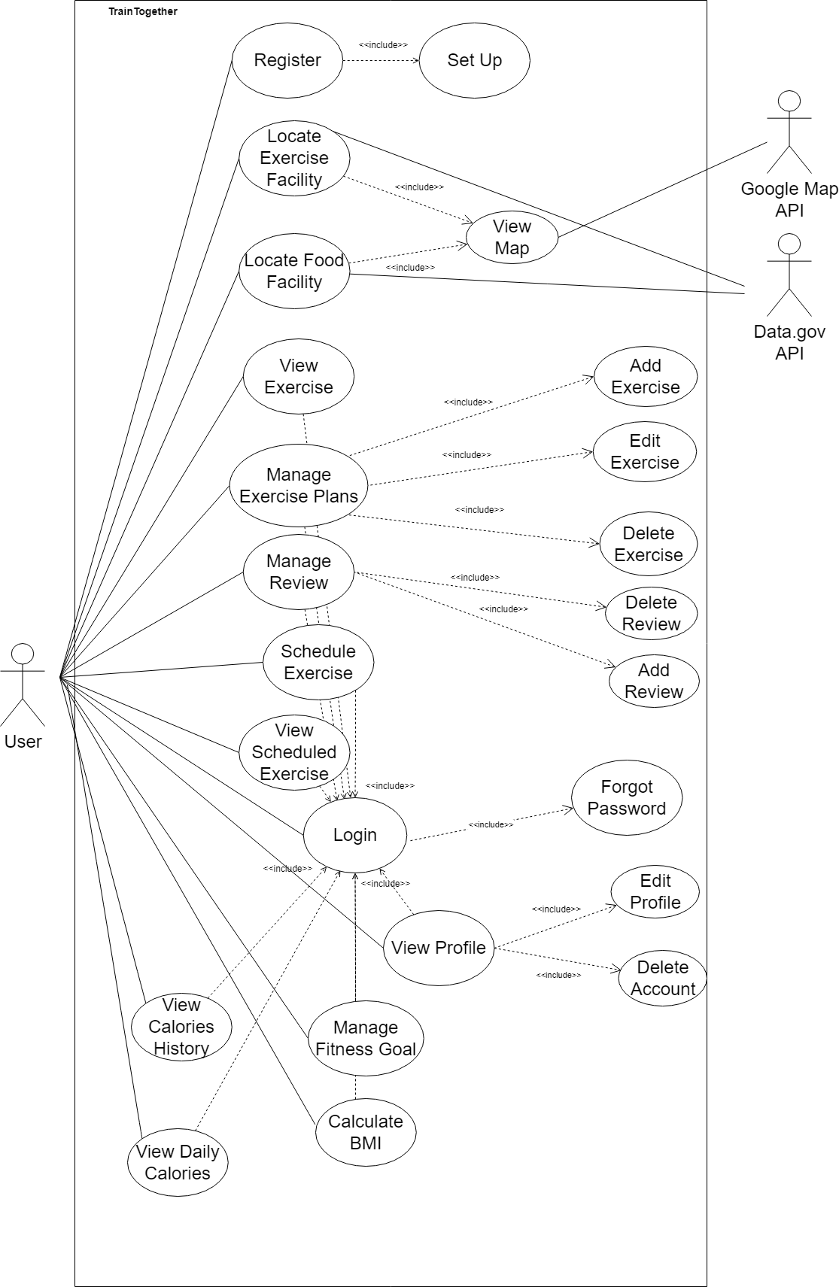

## Use Case Description

| Use Case ID: | 001 | | |
| --- | --- | --- | --- |
| Use Case Name: | Register | | |
| Created By: | Tey Li Zhang Edmund | Last Updated By: | Tey Li Zhang Edmund |
| Date Created: | 18 February 2023 | Date Last Updated: | 6 April 2023 |

| Actor: | User |
| --- | --- |
| Description: | This use case allows users to create an account in the system to access the application’s functions. The user has to enter a unique email address for registration and cannot use an email that has already been registered. |
| Preconditions: | 1. User must be in the Register page |
| Postconditions: | 1. System creates an account 2. System displays the profile page |
| Priority: | High |
| Frequency of Use: | 1/session |
| Flow of Events: | 1. User inputs their username, name, email address, password and re-enter their password into the form 2. User submits the form 3. System validates the username, name, email address, password and the re-entered password 4. System creates account 5. System triggers Set Up use case 6. System displays profile page |
| Alternative Flows: | 1. AF-S1: User already has account and clicks on login    1. System triggers Login use case |
| Exceptions: | 001.EX.1 User provides incomplete information during registration   1. System will display “Missing information. Please enter the required fields.” 2. System prompts the User to enter their details 3. Use case resumes at main flow step 1   001.EX.2 User provides an email address that has been used   1. System will display “Email has been used. Please register with another email or login with an existing account.” 2. System prompts the User to enter their details 3. Use case resumes at main flow step 1 |
| Includes: | Set Up, Register with Google Account |
| Extends | NIL |
| Special Requirements: | NIL |
| Assumptions: | * User enters in a valid phone number and email address |
| Notes and Issues: | NIL |

| Use Case ID: | 002 | | |
| --- | --- | --- | --- |
| Use Case Name: | Set Up | | |
| Created By: | Tey Li Zhang Edmund | Last Updated By: | Tey Li Zhang Edmund |
| Date Created: | 6 April 2023 | Date Last Updated: | 6 April 2023 |

| Actor: | User |
| --- | --- |
| Description: | This use case allows users to fill in additional information for their account. |
| Preconditions: | 1. User must have already registered for an account 2. User must not have set up their account |
| Postconditions: | 1. System insert additional information into the User’s account |
| Priority: | High |
| Frequency of Use: | 1/session |
| Flow of Events: | 1. System displays a form which contains Date of Birth, Phone Number, Height in cm, Weight in kg, dropdown menu for gender and file input for Profile Picture. 2. User inputs Date of Birth, Phone Number, Height, Weight, select their gender and upload their Profile Picture. 3. User submits the form. 4. System validates the form. 5. System insert additional information in the form to the User’s account |
| Alternative Flows: | NIL |
| Exceptions: | 002.EX.1 User submitted invalid inputs in the form   1. System displays error message for the invalid input 2. System prompts User to enter their details again 3. Use case resumes at the main flow step 1 |
| Includes: | NIL |
| Extends | NIL |
| Special Requirements: | NIL |
| Assumptions: | * User entered their actual Phone Number, Date of Birth, Weight, Height, Gender |
| Notes and Issues: | NIL |

| Use Case ID: | 003 | | |
| --- | --- | --- | --- |
| Use Case Name: | Login | | |
| Created By: | Low Zhan Long | Last Updated By: | Tey Li Zhang Edmund |
| Date Created: | 2 February 2023 | Date Last Updated: | 6 April 2023 |

| Actor: | User |
| --- | --- |
| Description: | This use case allows the user to login into the system to access the relevant functions of the application. To login to the system, all users have to enter their unique email address and their password. |
| Preconditions: | 1. User does not have an existing session cookie 2. User has a valid account |
| Postconditions: | 1. System displays the profile page |
| Priority: | High |
| Frequency of Use: | 1/session |
| Flow of Events: | 1. User inputs his email into the System 2. User inputs his password into the System 3. User submits email and password to the System 4. System verifies the email and password 5. System displays the user’s profile page |
| Alternative Flows: | 1. AF-S1: User forgets password and choose Forget Password    1. System trigger Forget Password use case |
| Exceptions: | 003.EX.1 User enters Invalid email or password   1. System displays “Invalid email and/or password” message 2. System prompts for email and password 3. Use case resumes at main flow step 1. |
| Includes: | Forget Password |
| Extends | NIL |
| Special Requirements: | * System should hash and salt the password entered by the User to verify if the hashed passwords match |
| Assumptions: | * Users should not be able to brute force and try out all the emails and passwords to gain entry into the system |
| Notes and Issues: | NIL |

| Use Case ID: | 004 | | |
| --- | --- | --- | --- |
| Use Case Name: | Forget Password | | |
| Created By: | Tey Li Zhang Edmund | Last Updated By: | Tey Li Zhang Edmund |
| Date Created: | 11 April 2023 | Date Last Updated: | 11 April 2023 |

| Actor: | User |
| --- | --- |
| Description: | This use case allows the user to reset their password. A password reset link will be sent to the account that the user registered with. |
| Preconditions: | 1. User must have an account registered 2. User is in Forgot Password Page |
| Postconditions: | 1. Password reset link is sent to User 2. System update password of User |
| Priority: | Medium |
| Frequency of Use: | 1/session |
| Flow of Events: | 1. System displays Forgot Password 2. User enters their email address 3. User submits their email address 4. System validates the email address 5. System verifies the email address 6. System send reset link to the email address 7. System displays “A password reset link has been sent to your email.” 8. User click on reset link in email 9. User is redirected back to the TrainTogether 10. User enters their new password and re-enters their password for confirmation 11. User submit password 12. System validates the password 13. System updates the password for the User 14. System directs user to log in page |
| Alternative Flows: | NIL |
| Exceptions: | 004.EX.1 User submitted invalid email format   1. System displays “Invalid Email Format” 2. System prompts User to enter their details again 3. Use case resumes at the main flow step 1   004.EX.2 User submitted email that is not registered   1. System displays “Email is not registered to an account” 2. System prompts User to enter their details again 3. Use case resumes at the main flow step 1   004.EX.3 User submitted password that does not contain at least one Uppercase, Lowercase, one number and special character   1. System displays “Password must contain at least one Uppercase, Lowercase, one number and special character” 2. System prompts User to enter their details again 3. Use case resumes at the main flow step 9 |
| Includes: | NIL |
| Extends | NIL |
| Special Requirements: | NIL |
| Assumptions: | NIL |
| Notes and Issues: | NIL |

| Use Case ID: | 005 | | |
| --- | --- | --- | --- |
| Use Case Name: | Locate Exercise Facility | | |
| Created By: | Tey Li Zhang Edmund | Last Updated By: | Tey Li Zhang Edmund |
| Date Created: | 6 April 2023 | Date Last Updated: | 6 April 2023 |

| Actor: | User, Google Map, Data Gov API |
| --- | --- |
| Description: | This use case allows users to locate exercise facilities in Singapore and receive information about the name, location, opening hours and website of the exercise facility. |
| Preconditions: | 1. User must have an account 2. User must have been logged in 3. User must be in the Exercise Facility Tab |
| Postconditions: | NIL |
| Priority: | High |
| Frequency of Use: | 5/session |
| Flow of Events: | 1. System triggers the View Map use case 2. User selects an Exercise Facility for more information 3. System query Data Gov API to get the Exercise Facility name, location, opening hours and website. 4. System displays the queried data |
| Alternative Flows: | NIL |
| Exceptions: | NIL |
| Includes: | View Map |
| Extends: | NIL |
| Special Requirements: | NIL |
| Assumptions: | NIL |
| Notes and Issues: | NIL |

| Use Case ID: | 006 | | |
| --- | --- | --- | --- |
| Use Case Name: | Locate Food Facility | | |
| Created By: | Tey Li Zhang Edmund | Last Updated By: | Solomon Tneo |
| Date Created: | 5 February 2023 | Date Last Updated: | 11 April 2023 |

| Actor: | User, Google Map, Data Gov API |
| --- | --- |
| Description: | This use case allows users to locate healthy food facilities in Singapore and receive information about the store name, food type, dining guidelines, venue type and health category |
| Preconditions: | 1. User must have an account 2. User must be logged in 3. User must be in the Hungry Go Where tab |
| Postconditions: | 1. System shows details of the food store |
| Priority: | High |
| Frequency of Use: | 1/session |
| Flow of Events: | 1. User clicks on HungryGoWhere in the Header 2. System triggers the View Map use case 3. User can filter Food Facility from the food type, dining guidelines, venue type and health category 4. User selects a location for more information 5. System query Data Gov API to get the Food Facility name, location, opening hours and website 6. System displays the store name, food type, dining guidelines, venue type and health category |
| Alternative Flows: | NIL |
| Exceptions: | 006.EX.1 User does not enter any food requirements   1. System will display all available food stores |
| Includes: | NIL |
| Extends | View Map |
| Special Requirements: | NIL |
| Assumptions: | NIL |
| Notes and Issues: | * There are 5 filters for users to use to filter food stores, including, health category, food type, dining guideline, venue and regions. * For health category, the available options are: lower in sugar, higher in wholegrains, lower in calories, no added sugar, source of dietary fibre, eat 2+2 serving of fruits, vegetables daily * For food type, the available options are: drinks, bread, cakes, cookies, pastries, Western, desserts, snacks and kuih, bubble tea, Chinese, fast food, Malay, Thai, cut fruit, Japanese, Korean, local flavours, Fusion, Indian * For dining guideline, the available options are Halal and Non-Halal * For venue, the available options are: hawker centre, bakery, cafe, kiosk, restaurant, fast food, coffee shop, dessert, f&b on digital platforms * For regions, the available options are: North, East, Central, North-East, West * User can click on ‘Reset’ to reset the filter |

| Use Case ID: | 007 | | |
| --- | --- | --- | --- |
| Use Case Name: | View Map | | |
| Created By: | Tey Li Zhang Edmund | Last Updated By: | Solomon Tneo |
| Date Created: | 5 February 2023 | Date Last Updated: | 11 April 2023 |

| Actor: | User, Google |
| --- | --- |
| Description: | Able to navigate, scroll and zoom on location of exercise facility or food facility |
| Preconditions: | 1. User must have an account 2. User must have been logged in 3. User must be in the Exercise Facility Tab or Hungry Go Where Tab |
| Postconditions: | 1. System shows Map |
| Priority: | High |
| Frequency of Use: | 5/session |
| Flow of Events: | 1. User clicks on Exercise facilities tab 2. System displays a map of the user’s current location 3. System request Google for the Google Maps 4. User zoom in or out using punch gestures or using their mouse gestures 5. System updates map based on gestures 6. User scroll around the map by dragging it with their mouse 7. System updates map based on gesture 8. User can query for a specific location on the map by typing into the search bar 9. System updates map based on query. |
| Alternative Flows: | 1. AF-S1: User clicks on Hungry Go Where tab    1. System displays a map of the user’s current location    2. System request Google for the Google Maps    3. User zoom in or out using punch gestures or using their mouse gestures    4. System updates map based on gestures    5. User scroll around the map by dragging it with their mouse    6. System updates map based on gestures    7. User can query for a specific location on the map by typing into the search bar    8. System updates map based on query. |
| Exceptions: | 007.EX.1 User query a location that does not exist on the map   1. System will display “Location does not exist” 2. Use case resumes at the main flow at step 4 |
| Includes: | NIL |
| Extends | NIL |
| Special Requirements: | NIL |
| Assumptions: | NIL |
| Notes and Issues: | NIL |

| Use Case ID: | 008 | | |
| --- | --- | --- | --- |
| Use Case Name: | View Exercises | | |
| Created By: | Low Zhan Long | Last Updated By: | Solomon Tneo |
| Date Created: | 2 February 2023 | Date Last Updated: | 11 April 2023 |

| Actor: | User |
| --- | --- |
| Description: | Able to view exercises’ instructions and remarks |
| Preconditions: | 1. User must have an account 2. User must login 3. User must have rights, privilege and access |
| Postconditions: | 1. System displays exercise’s instructions and remarks |
| Priority: | Medium |
| Frequency of Use: | 1/Session |
| Flow of Events: | 1. User logs in using the included use case Login 2. User clicks on Workout 3. System displays Workout page 4. User able to view Exercises 5. User selects an exercise 6. System displays exercise’s instructions and remarks |
| Alternative Flows: | NIL |
| Exceptions: | NIL |
| Includes: | Login |
| Special Requirements: | NIL |
| Assumptions: | NIL |
| Notes and Issues: | * System is to sort exercises according to body parts, which are: Arms, Back, Cardio, Core and Legs |

| Use Case ID: | 009 | | |
| --- | --- | --- | --- |
| Use Case Name: | Manage Exercise Plan | | |
| Created By: | Low Zhan Long | Last Updated By: | Solomon Tneo |
| Date Created: | 2 February 2023 | Date Last Updated: | 13 April 2023 |

| Actor: | User |
| --- | --- |
| Description: | This use case allows users to manage their exercise plans. Users are able to add, edit and delete their exercise plan. |
| Preconditions: | 1. User must have an account 2. User must login 3. User must have rights, privilege and access |
| Postconditions: | 1. System displays exercise plans that user desires |
| Priority: | Medium |
| Frequency of Use: | 1/Session |
| Flow of Events: | 1. User logs in using the included use case Login 2. User clicks on Workout 3. System displays Workout page 4. System displays list of exercise plans and add exercise plan button 5. User selects an exercise plan to view more information 6. System displays the name of the exercise plan and the list of exercises tagged in the exercise plan 7. System displays edit exercise plan button and delete exercise plan button 8. User can select to add, edit and delete exercise plan |
| Alternative Flows: | 1. AF-S7: User selects add exercise plan    1. System displays add exercise plan page    2. User enters name of exercise plan    3. User uploads a picture for the exercise plan    4. User selects on exercises to be added    5. System trigger Add Exercise use case    6. User clicks “Save”.    7. System adds the new exercise plan to the database    8. Use case resumes at main flow step 3 2. AF-S7: Users selects delete exercise plan    1. System triggers Delete Exercise use case    2. Systems deletes the exercise plan from the database    3. Use case resumes at main flow step 3 3. AF-S7: Users selects edit exercise plan    1. System display edit exercise plan page    2. User enters new name of exercise plan    3. User uploads a new picture for the exercise plan    4. System triggers Edit Exercise use case    5. User selects submit    6. System saves exercise plans detail and updates database    7. Use case resumes at main flow at step 3 |
| Exceptions: | 009.EX.1. Exercise Plans have no exercises   * System will display “no exercise” message   009.EX.2. Users did not create any exercise plans   * System will display list of default exercise plans |
| Includes: | Login, Add Exercise, Edit Exercise, Delete Exercise |
| Special Requirements: | NIL |
| Assumptions: | NIL |
| Notes and Issues: | * System has a list of default exercise plans for each fitness corners shown on the map |

| Use Case ID: | 010 | | |
| --- | --- | --- | --- |
| Use Case Name: | Add Exercise | | |
| Created By: | Low Zhan Long | Last Updated By: | Tey Li Zhang Edmund |
| Date Created: | 2 February 2023 | Date Last Updated: | 12 April 2023 |

| Actor: | User |
| --- | --- |
| Description: | Able to add exercise into an exercise plan |
| Preconditions: | 1. User must have an account 2. User must login 3. User must have rights, privilege and access 4. User must have created at least 1 exercise plan |
| Postconditions: | 1. Exercise is added into the exercise plan |
| Priority: | Medium |
| Frequency of Use: | 2/Session |
| Flow of Events: | 1. User logs in using the included use case Login 2. User clicks on Workout 3. System displays Workout page 4. User clicks on add exercise plan 5. User enters name of exercise plan 6. User chooses an exercise group 7. System displays list of exercises tagged under the chosen exercise group 8. System selects the “plus icon” beside the exercise name 9. User edits the exercise’s reps and sets 10. User selects save 11. System adds the new exercise plan into the list of exercise plans as well as into the database and displays added exercises in the exercise plan. |
| Alternative Flows: | 1. AF-S3 Users selects edit exercise plan    1. System displays list of exercises tagged under the chosen exercise group    2. User adds exercise to the exercise plan    3. User edits the exercise’s reps and sets    4. User selects submit    5. System adds new exercise plan to the database    6. System displays added exercises in the exercise plan. |
| Exceptions: | 008.EX.1. Users did not create any exercise plans   * User is unable to add exercise |
| Includes: | Login, Manage Exercise Plan |
| Extends: | NIL |
| Special Requirements: | NIL |
| Assumptions: | * User’s desired exercise is available in TrainTogether App * User is able to carry out the exercise add at user’s desired location |
| Notes and Issues: | * User does not have rights to add exercise for default exercise plans |

| Use Case ID: | 011 | | |
| --- | --- | --- | --- |
| Use Case Name: | Edit Exercise | | |
| Created By: | Low Zhan Long | Last Updated By: | Tey Li Zhang Edmund |
| Date Created: | 2 February 2023 | Date Last Updated: | 12 April 2023 |

| Actor: | User |
| --- | --- |
| Description: | Able to edit exercise in an exercise plan |
| Preconditions: | 1. User must have an account 2. User must login 3. User must have rights, privilege and access 4. User must have created at least 1 exercise plan 5. User must have added at least 1 exercise |
| Postconditions: | 1. Exercise edited in the exercise plan |
| Priority: | Medium |
| Frequency of Use: | 0-1/Session |
| Flow of Events: | 1. User clicks on Workout 2. System displays Workout page 3. User clicks on an exercise plan 4. System displays list of exercises tagged under the chosen exercise plan 5. User selects edit exercise beside the exercise name 6. System displays list of exercises tagged under the chosen exercise group 7. User selects the “plus icon” beside the exercise name 8. User edits the exercise’s reps and sets 9. User selects submit 10. System updates the exercise plan in the database 11. System displays updated exercises in the exercise plan. |
| Alternative Flows: | NIL |
| Exceptions: | 009.EX.1. Users did not create any exercise plans   * User is unable to edit exercise   009 EX 2. Users did not add exercise in exercise plans   * User is unable to edit exercise |
| Includes: | Login |
| Extends: | Manage Exercise Plan |
| Special Requirements: | NIL |
| Assumptions: | * User’s desired exercise is available in TrainTogether App * User is able to carry out the exercise add at user’s desired location |
| Notes and Issues: | * User does not have rights to edit exercise for default exercise plans |

| Use Case ID: | 012 | | |
| --- | --- | --- | --- |
| Use Case Name: | Delete Exercise | | |
| Created By: | Low Zhan Long | Last Updated By: | Solomon Tneo |
| Date Created: | 2 February 2023 | Date Last Updated: | 12 April 2023 |

| Actor: | User |
| --- | --- |
| Description: | Able to delete exercise from an exercise plan |
| Preconditions: | 1. User must have an account 2. User must login 3. User must have rights, privilege and access 4. User must have created at least 1 exercise plan 5. User must have added at least 1 exercise |
| Postconditions: | 1. Exercise deleted in the exercise plan |
| Priority: | Medium |
| Frequency of Use: | 0-1/Session |
| Flow of Events: | 1. User clicks on Workout 2. System displays Workout page 3. User clicks on an exercise plan 4. System displays list of exercises tagged under the chosen exercise plan 5. User selects the edit exercise besides the exercise name 6. System displays list of exercises tagged under the chosen exercise group 7. User selects the delete exercise plan button beside the exercise name 8. System remove exercise from the exercise plan 9. User selects submit 10. System displays updated exercise plans. |
| Alternative Flows: | NIL |
| Exceptions: | 010.EX.1. Users did not create any exercise plans   * User is unable to delete exercise   010 EX 2. Users did not add exercise in exercise plans   * User is unable to delete exercise |
| Includes: | Login |
| Extends: | Manage Exercise Plan |
| Special Requirements: | NIL |
| Assumptions: | NIL |
| Notes and Issues: | * User does not have rights to delete exercise for default exercise plans |

| Use Case ID: | 013 | | |
| --- | --- | --- | --- |
| Use Case Name: | Manage Review | | |
| Created By: | Low Zhan Long | Last Updated By: | Wan Kai Jie |
| Date Created: | 2 February 2023 | Date Last Updated: | 13 April 2023 |

| Actor: | User |
| --- | --- |
| Description: | Able to Manage Review about Exercise |
| Preconditions: | 1. User must have selected the Exercise |
| Postconditions: | NIL |
| Priority: | Low |
| Frequency of Use: | 1/session |
| Flow of Events: | 1. User logs in using the included use case Login 2. System displays a list of Exercises under the Exercise Group 3. User selects an Exercise 4. System displays details about the selected Exercise 5. User clicks to ‘Review’ to view the reviews of the selected Exercise 6. System displays the list of reviews tagged to the particular Exercise |
| Alternative Flows: | 1. AF: User view reviews from dashboard    1. User clicks on reviews from dashboard    2. System displays all the reviews from all exercises 2. AF-S5: User selects add review    1. System displays add review page    2. System trigger Add Review use case    3. System adds the new review to the database    4. Use case resumes at main flow step 5 3. AF: Users selects delete review    1. User clicks on Profile    2. User clicks on Reviews component    3. System triggers Delete Review use case    4. Systems deletes the review from the database    5. Use case resumes at alternative flow step 3 |
| Exceptions: | NIL |
| Includes: | Login, Add Review, Delete Review |
| Extends: | NIL |
| Special Requirements: | NIL |
| Assumptions: | NIL |
| Notes and Issues: | NIL |

| Use Case ID: | 014 | | |
| --- | --- | --- | --- |
| Use Case Name: | Add Review | | |
| Created By: | Low Zhan Long | Last Updated By: | Wan Kai Jie |
| Date Created: | 2 February 2023 | Date Last Updated: | 13 April 2023 |

| Actor: | User |
| --- | --- |
| Description: | Able to Add Review about Exercise |
| Preconditions: | 1. User must have selected the Exercise 2. User must be logged in |
| Postconditions: | 1. The new review is added to database |
| Priority: | Low |
| Frequency of Use: | 1/Exercise Plan |
| Flow of Events: | 1. User clicks on Workout 2. System displays Workout page 3. User selects an Exercise Group 4. User select an Exercise 5. User clicks view Review on selected Exercise 6. User clicks add Review on selected Exercise 7. User input details of Review Details 8. User clicks Submit 9. System generates a Review for Exercise |
| Alternative Flows: | NIL |
| Exceptions: | 014.EX.1 User provides does not give a rating when submitting a review   * System will display an error message and prompts the user to give a rating |
| Includes: | NIL |
| Extends | NIL |
| Special Requirements: | NIL |
| Assumptions: | NIL |
| Notes and Issues: | NIL |

| Use Case ID: | 015 | | |
| --- | --- | --- | --- |
| Use Case Name: | Delete Review | | |
| Created By: | Low Zhan Long | Last Updated By: | Wan Kai Jie |
| Date Created: | 2 February 2023 | Date Last Updated: | 12 April 2023 |

| Actor: | User |
| --- | --- |
| Description: | Able to Delete Review about Exercise |
| Preconditions: | 1. User must have done a review about an exercise before 2. User must be logged in |
| Postconditions: | 1. The particular review is deleted from database |
| Priority: | Low |
| Frequency of Use: | 1/Review |
| Flow of Events: | 1. User clicks on Profile 2. User clicks on Reviews component 3. User selects the Review 4. User clicks the delete button to delete the review 5. System deletes Review |
| Alternative Flows: | NIL |
| Exceptions: | NIL |
| Includes: | NIL |
| Extends: | NIL |
| Special Requirements: | NIL |
| Assumptions: | * User is sure of the choice to delete the review |
| Notes and Issues: | * There is no editing of reviews available, hence a user is required to delete the review before adding a new one if there are any edits the user wants to make to a review |

| Use Case ID: | 016 | | |
| --- | --- | --- | --- |
| Use Case Name: | Schedule Exercise | | |
| Created By: | Low Zhan Long | Last Updated By: | Wan Kai Jie |
| Date Created: | 2 February 2023 | Date Last Updated: | 12 April 2023 |

| Actor: | User |
| --- | --- |
| Description: | Able to schedule an exercise plan |
| Preconditions: | 1. There must be at least one exercise plan available to be scheduled for |
| Postconditions: | 1. Newly scheduled exercise plan is added to database |
| Priority: | Medium |
| Frequency of Use: | 1/Exercise Plan |
| Flow of Events: | 1. User logs in using the included use case Login 2. User clicks onto the Schedule Exercise button 3. User input schedule details 4. User clicks Submit 5. System updates newly scheduled exercise |
| Alternative Flows: | NIL |
| Exceptions: | NIL |
| Includes: | Login |
| Extends: | NIL |
| Special Requirements: | NIL |
| Assumptions: | * User only schedules an exercise plan that is on a future date and time |
| Notes and Issues: | * User is able to reset the Exercise Plan to the default one when inputting schedule details |

| Use Case ID: | 017 | | |
| --- | --- | --- | --- |
| Use Case Name: | View Scheduled Exercise | | |
| Created By: | Low Zhan Long | Last Updated By: | Wan Kai Jie |
| Date Created: | 2 February 2023 | Date Last Updated: | 12 April 2023 |

| Actor: | User |
| --- | --- |
| Description: | Able to view Scheduled Exercise from profile |
| Preconditions: | 1. User must have an account |
| Postconditions: | NIL |
| Priority: | Medium |
| Frequency of Use: | 1/Session |
| Flow of Events: | 1. User logs in using the included use case Login 2. User clicks Profile 3. User selects Scheduled Exercise component 4. System displays all Scheduled Exercises belonging to the user |
| Alternative Flows: | NIL |
| Exceptions: | NIL |
| Includes: | Login |
| Extends: | NIL |
| Special Requirements: | NIL |
| Assumptions: | NIL |
| Notes and Issues: | * Scheduled Exercises are ordered according to date from the closest to the furthest date, in the Scheduled Exercise component page |

| Use Case ID: | 018 | | |
| --- | --- | --- | --- |
| Use Case Name: | View Profile | | |
| Created By: | Lee Yen Foong Ernest | Last Updated By: | Wan Kai Jie |
| Date Created: | 2 February 2023 | Date Last Updated: | 12 April 2023 |

| Actor: | User |
| --- | --- |
| Description: | This use case allows the user to view his account from the settings function |
| Preconditions: | 1. User must have an account |
| Postconditions: | 1. User is able to view his account 2. User is unable to login into the same account |
| Priority: | Medium |
| Frequency of Use: | 1/session |
| Flow of Events: | 1. User logs in using the included use case Login 2. User clicks Profile 3. System displays User dashboard 4. User clicks on the Settings button 5. User clicks on Account button 6. System displays basic profile details 7. If user selects edit profile, System triggers the Edit Profile use case 8. If user selects delete account, System triggers the Delete Profile use case |
| Alternative Flows: | NIL |
| Exceptions: | NIL |
| Includes: | Login, Edit Profile, Delete Account |
| Extends: | NIL |
| Special Requirements: | NIL |
| Assumptions: | NIL |
| Notes and Issues: | * User is able to view other types of profile details in the dashboard page, which is demonstrated in other use cases |

| Use Case ID: | 019 | | |
| --- | --- | --- | --- |
| Use Case Name: | Edit Profile | | |
| Created By: | Low Zhan Long | Last Updated By: | Wan Kai Jie |
| Date Created: | 2 February 2023 | Date Last Updated: | 12 April 2023 |

| Actor: | User |
| --- | --- |
| Description: | This use case allows the user to edit and update his own profile information |
| Preconditions: | 1. User must have an account 2. User must be logged in |
| Postconditions: | 1. New Details have been updated |
| Priority: | Medium |
| Frequency of Use: | 1/session |
| Flow of Events: | 1. User clicks onto Profile 2. System displays User dashboard 3. User clicks on Account Settings 4. User edits information about Account 5. User clicks Done Button 6. System update Profile |
| Alternative Flows: | NIL |
| Exceptions: | 019.EX.1 User enters invalid username, mobile number or email address   * System will display an error message and prompt user to re-enter their particulars again |
| Includes: | NIL |
| Extends | NIL |
| Special Requirements: | NIL |
| Assumptions: | * User should enter in a valid username, mobile number and email address |
| Notes and Issues: | * User is also able to switch to Notifications segment to update notification settings * User is also able to switch to Security segment to change their password |

| Use Case ID: | 020 | | |
| --- | --- | --- | --- |
| Use Case Name: | Delete Account | | |
| Created By: | Low Zhan Long | Last Updated By: | Wan Kai Jie |
| Date Created: | 2 February 2023 | Date Last Updated: | 12 April 2023 |

| Actor: | User |
| --- | --- |
| Description: | This use case allows the user to delete his own account through the Account settings function |
| Preconditions: | 1. User must have an account 2. User must be logged in |
| Postconditions: | 1. User’s account has been deleted 2. User is unable to login into the same account 3. User will be redirected back to the login page |
| Priority: | Medium |
| Frequency of Use: | 1/session |
| Flow of Events: | 1. User clicks onto Profile 2. System displays User dashboard 3. User clicks on Account Settings 4. User clicks on Security segment 5. User clicks on Delete Account Button 6. System sends warning message to user 7. User clicks on Confirm Delete Account Button 8. System notifies user through email that account have been deleted 9. System logs User out of account and remove account |
| Alternative Flows: | NIL |
| Exceptions: | NIL |
| Includes: | NIL |
| Extends: | NIL |
| Special Requirements: | NIL |
| Assumptions: | * All relevant databases will also delete details related to the User * User is sure of the choice to delete their account, and is not accidental |
| Notes and Issues: | NIL |

| Use Case ID: | 021 | | |
| --- | --- | --- | --- |
| Use Case Name: | Manage Fitness Goals | | |
| Created By: | Tey Li Zhang Edmund | Last Updated By: | Lee Yen Foong Ernest |
| Date Created: | 5 February 2023 | Date Last Updated: | 13 April 2023 |

| Actor: | User |
| --- | --- |
| Description: | This use case allows the user to view all the fitness goals that he has created. User is able to add, edit and delete his fitness goals. |
| Preconditions: | 1. User must have an account 2. User must have at least one fitness goal when editing or deleting |
| Postconditions: | 1. User is able to view his updated fitness goals |
| Priority: | High |
| Frequency of Use: | 1/session |
| Flow of Events: | 1. User logs in using the included use case Login 2. System displays Profile Page 3. Profile Manager displays Dashboard Page 4. System renders ‘Manage Fitness Goal Page’ component 5. System retrieves User’s fitness goals 6. System displays user’s fitness goals in ‘Fitness Goal’ component |
| Alternative Flows: | 1. AF-S7: User decides to add a fitness goal    1. User clicks on ‘+’ button to add a new fitness goal    2. System displays ‘Add Fitness Goal Page’    3. User enter details of fitness goal    4. User clicks Submit button    5. System generates the updated fitness goals list    6. User clicks “Save”.    7. System adds the new fitness goal to the database 2. AF-S7: Users decides to edit fitness goal    1. User clicks on ‘Edit’ button to edit a fitness goal    2. System retrieves user’s fitness goals    3. System displays user’s fitness goals in ‘Edit Fitness Goal Page’    4. User changes details of the fitness goal and submit    5. System updates the fitness goal and displays updated fitness goals list in ‘Fitness Goal’ component in Dashboard Page 3. AF-S7: Users decides to delete fitness goal    1. User clicks on ‘Delete’ button to delete a fitness goal    2. System deletes the fitness goal    3. System generates the updated fitness goals list |
| Exceptions: | 021.EX.1 User provides incomplete details when adding fitness goal   * System will display an error message and prompts the user to enter the details correctly   021. EX.2 User provides incorrect details when adding fitness goal   * System will display an error message and prompts the user to enter the details correctly   021. EX.1 User provides incorrect details when editing fitness goal   * System will display an error message and prompts the user to enter the details correctly |
| Includes: | Login |
| Extends | NIL |
| Special Requirements: | NIL |
| Assumptions: | User enters all details of fitness goals correctly   1. Target value and current value must be an integer 2. Target date cannot be in the past 3. Target date cannot be more than 100 years in the future |
| Notes and Issues: | NIL |

| Use Case ID: | 022 | | |
| --- | --- | --- | --- |
| Use Case Name: | Calculate BMI | | |
| Created By: | Tey Li Zhang Edmund | Last Updated By: | Lee Yen Foong Ernest |
| Date Created: | 5 February 2023 | Date Last Updated: | 12 April 2023 |

| Actor: | User |
| --- | --- |
| Description: | This use case allows the user to calculate BMI using a height and weight value |
| Preconditions: | 1. User must have an account |
| Postconditions: | 1. User is able to view his BMI index value |
| Priority: | Medium |
| Frequency of Use: | 1/session |
| Flow of Events: | 1. User logs in using the included use case Login 2. System displays Profile Page 3. Profile Manager displays Dashboard Page 4. System renders ‘BMI Calculator’ component 5. System retrieves User’s height and weight and calculates BMI index 6. System displays BMI index value in ‘BMI Calculator’ component |
| Alternative Flows: | 1. AF6: User can input custom height and weight value    1. User inputs a different height or weight value    2. System displays new BMI index value in ‘BMI Calculator’ component |
| Exceptions: | NIL |
| Includes: | Login |
| Extends | NIL |
| Special Requirements: | NIL |
| Assumptions: | 1. User must input a Height and Weight value that is greater than 0 |
| Notes and Issues: | NIL |

| Use Case ID: | 023 | | |
| --- | --- | --- | --- |
| Use Case Name: | View Calories History | | |
| Created By: | Tey Li Zhang Edmund | Last Updated By: | Lee Yen Foong Ernest |
| Date Created: | 5 February 2023 | Date Last Updated: | 12 April 2023 |

| Actor: | User |
| --- | --- |
| Description: | This use case allows the user to be able to view his calories burnt history |
| Preconditions: | 1. User must have an account |
| Postconditions: | 1. User can see his calories burnt in the past |
| Priority: | High |
| Frequency of Use: | 1/session |
| Flow of Events: | 1. User logs in using the included use case Login 2. System displays Profile Page 3. Profile Manager displays Dashboard Page 4. System renders ‘Daily Calories’ component 5. System retrieves User’s calories history 6. System displays calories history in ‘View Calories History’ component |
| Alternative Flows: | NIL |
| Exceptions: | NIL |
| Includes: | Login |
| Extends | NIL |
| Special Requirements: | NIL |
| Assumptions: | NIL |
| Notes and Issues: | NIL |

| Use Case ID: | 024 | | |
| --- | --- | --- | --- |
| Use Case Name: | View Daily Calories | | |
| Created By: | Tey Li Zhang Edmund | Last Updated By: | Lee Yen Foong Ernest |
| Date Created: | 5 February 2023 | Date Last Updated: | 12 April 2023 |

| Actor: | User |
| --- | --- |
| Description: | This use case allows the user to be able to view his daily calories burnt |
| Preconditions: | 1. User must have an account |
| Postconditions: | 1. User can see his current calories burnt for the day |
| Priority: | High |
| Frequency of Use: | 1/session |
| Flow of Events: | 1. User logs in using the included use case Login 2. System displays Profile Page 3. Profile Manager displays Dashboard Page 4. System renders ‘View Daily Calories’ component 5. System retrieves User’s calories burnt today 6. System displays calories burnt in ‘View Daily Calories’ component |
| Alternative Flows: | NIL |
| Exceptions: | NIL |
| Includes: | Login |
| Extends | NIL |
| Special Requirements: | NIL |
| Assumptions: | NIL |
| Notes and Issues: | NIL |

## 8.3 Class Diagram

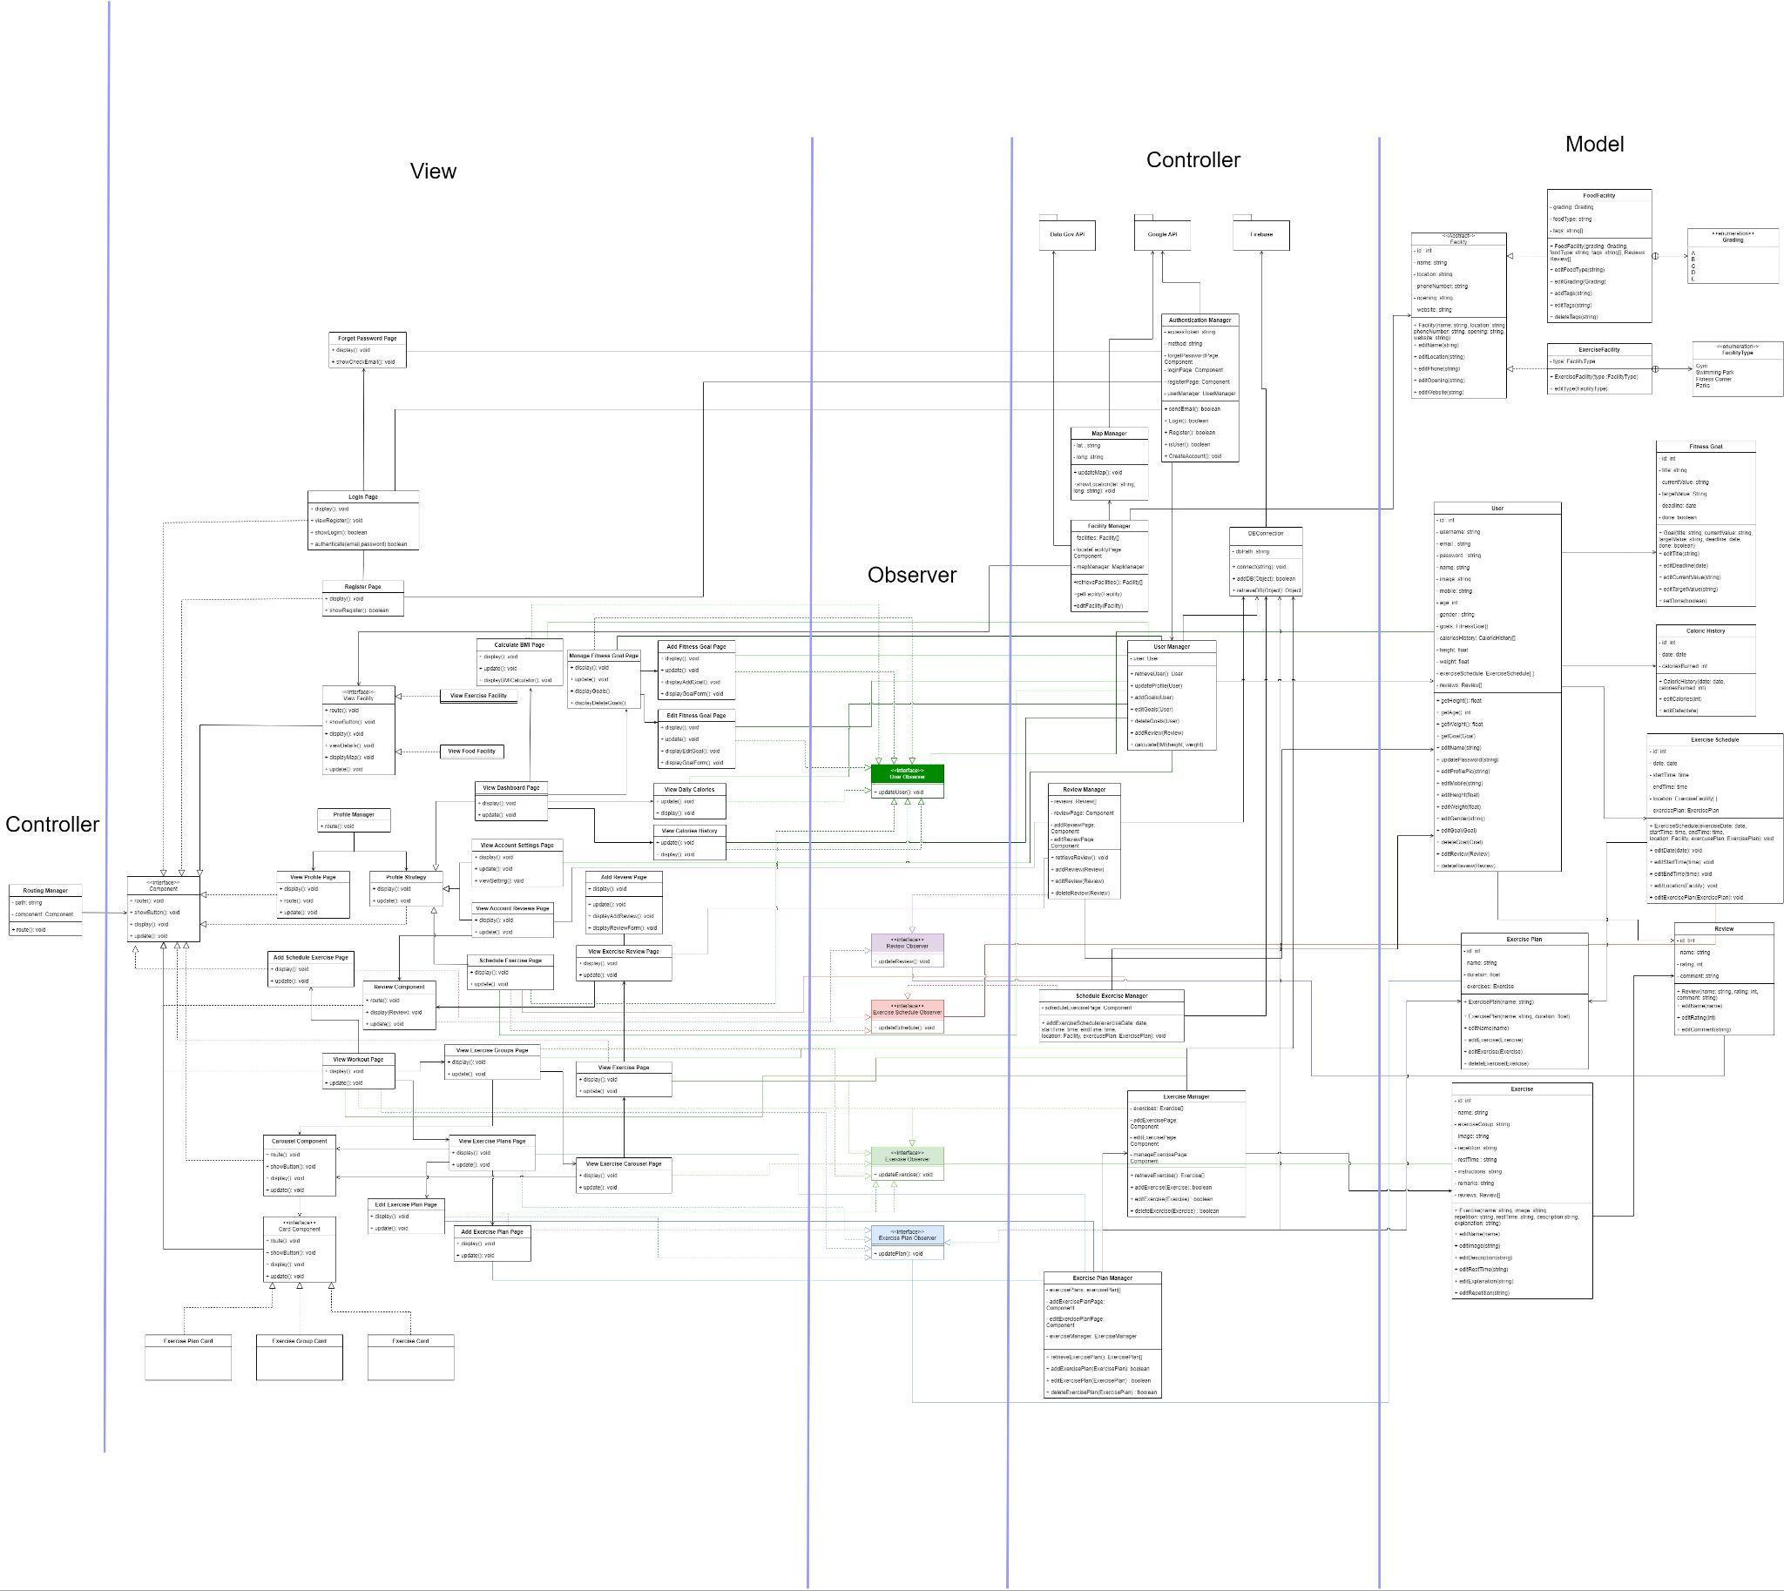

### 8.3.1 View and Routing Manager Class Diagram

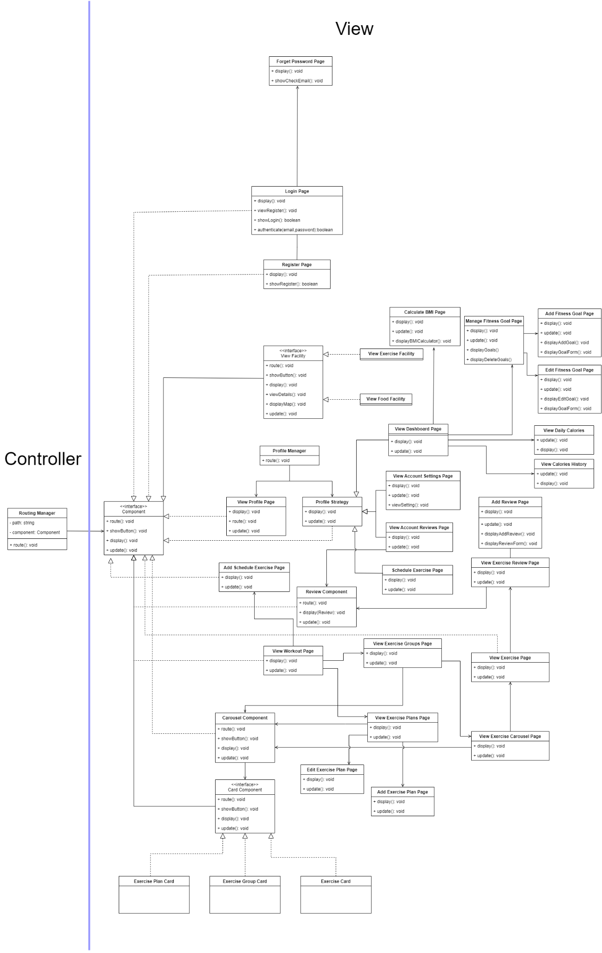

### 8.3.2 Observer and Controllers Class Diagram

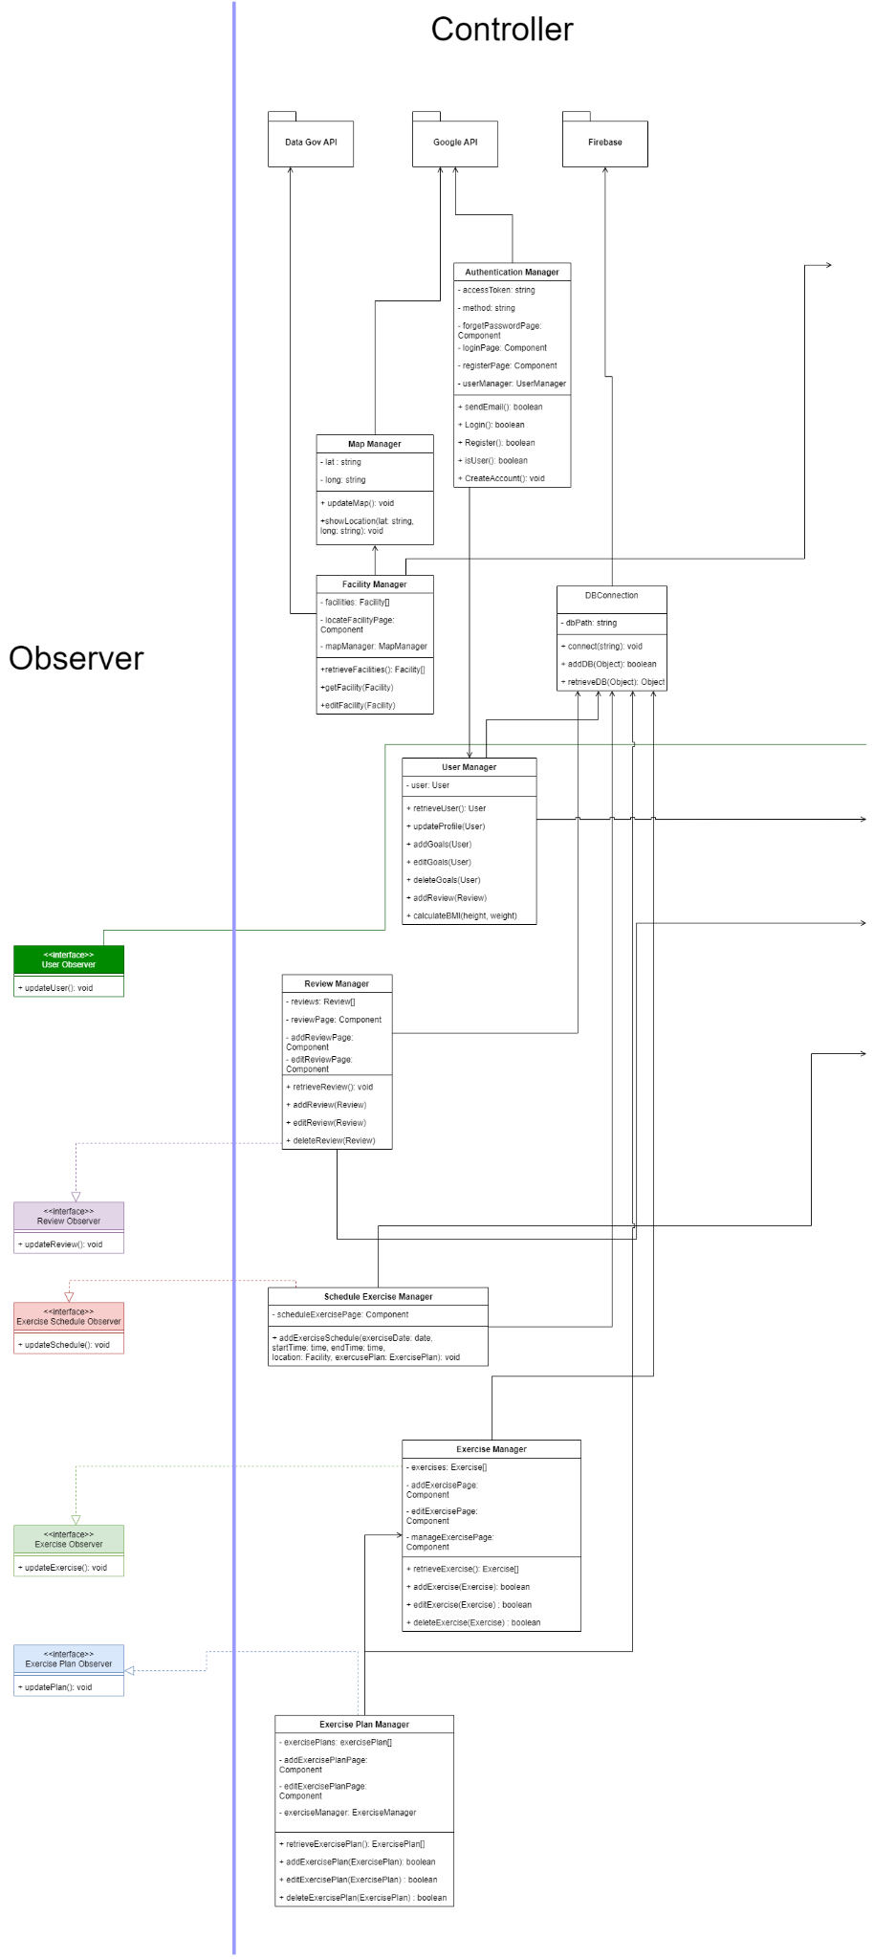

### 8.3.3 Models Class Diagram

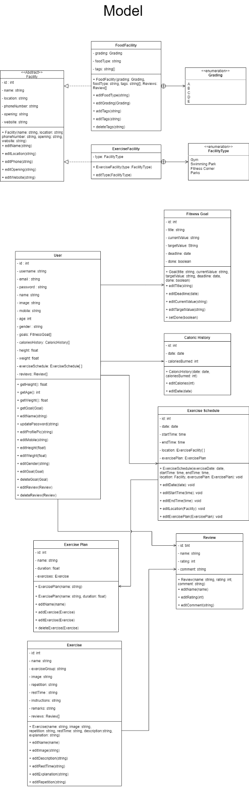

## 8.4 Dialog Map

8.4.1 Login Page

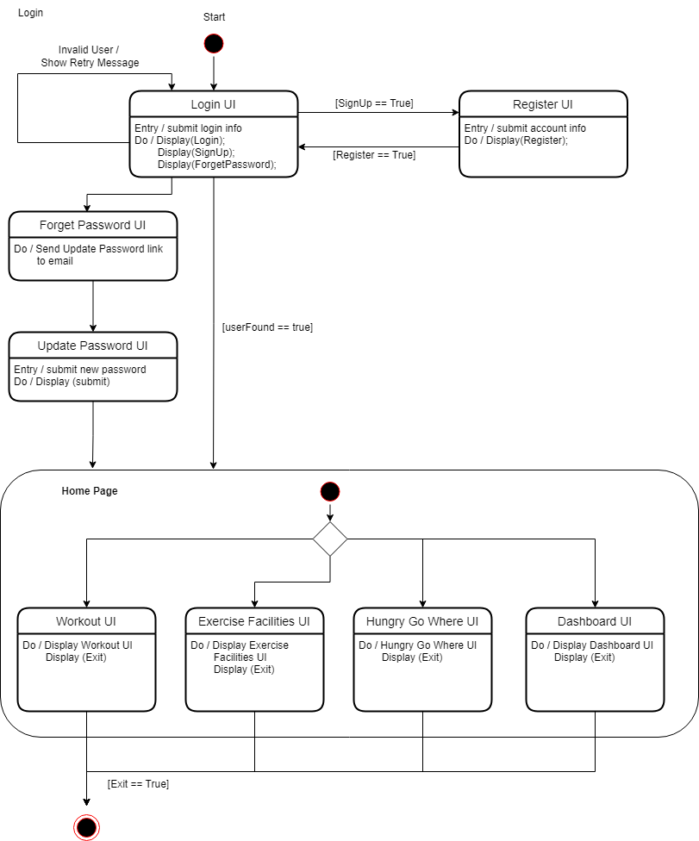

8.4.2 Dashboard Page

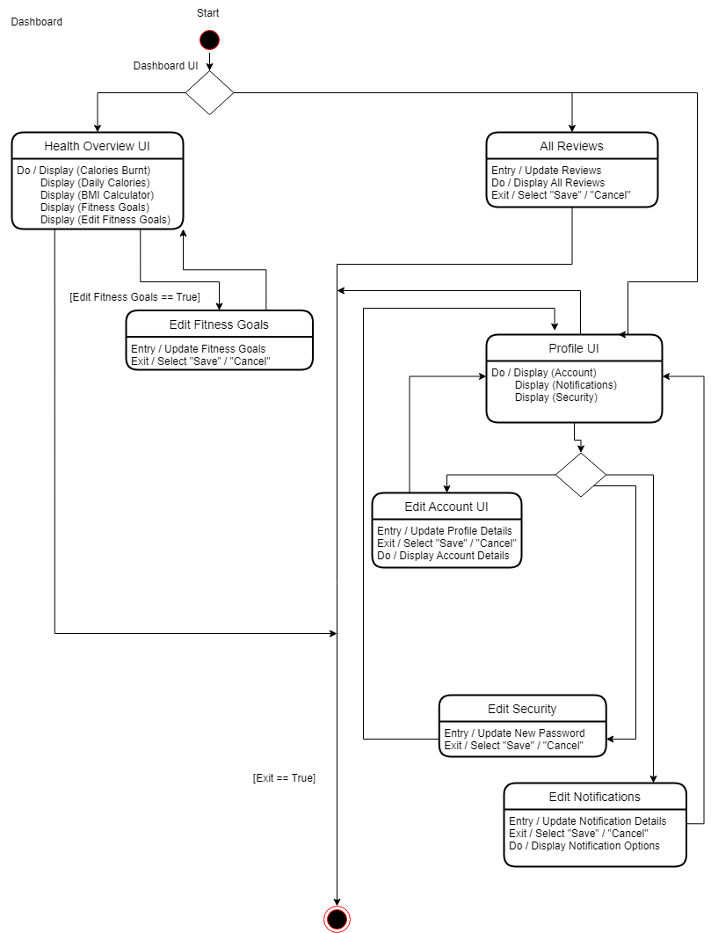

8.4.3 Hungry Go Where Page

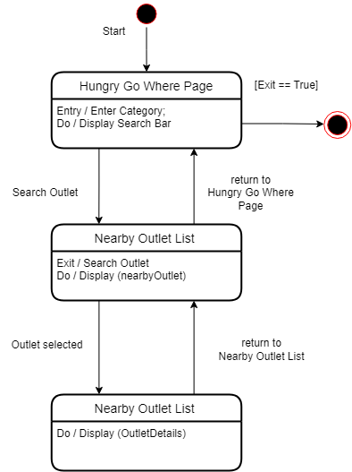

8.4.4 Exercise Facilities Page

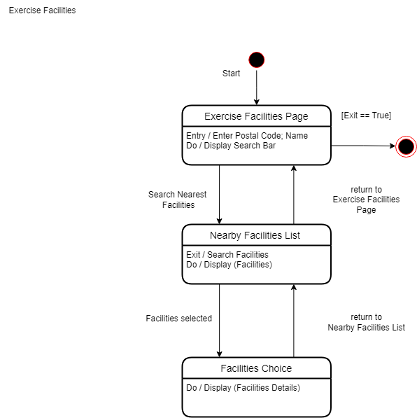

8.4.5 Workout Page

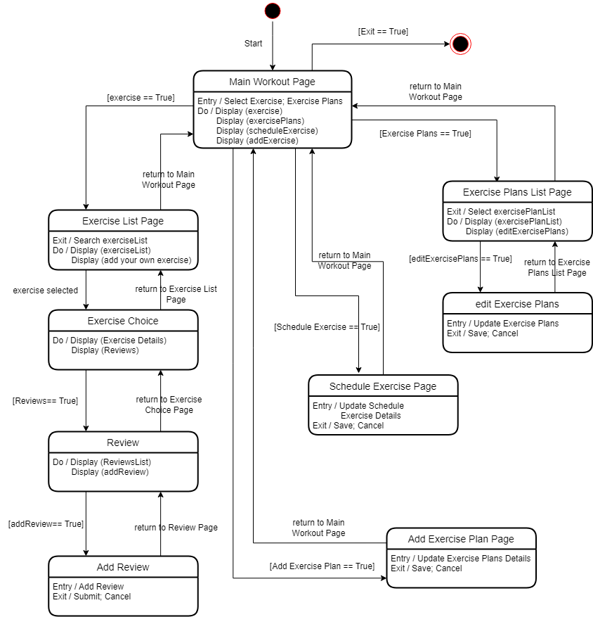

## 8.5 System Architecture



## 

## 8.6 Sequence Diagram

8.6.1 Register

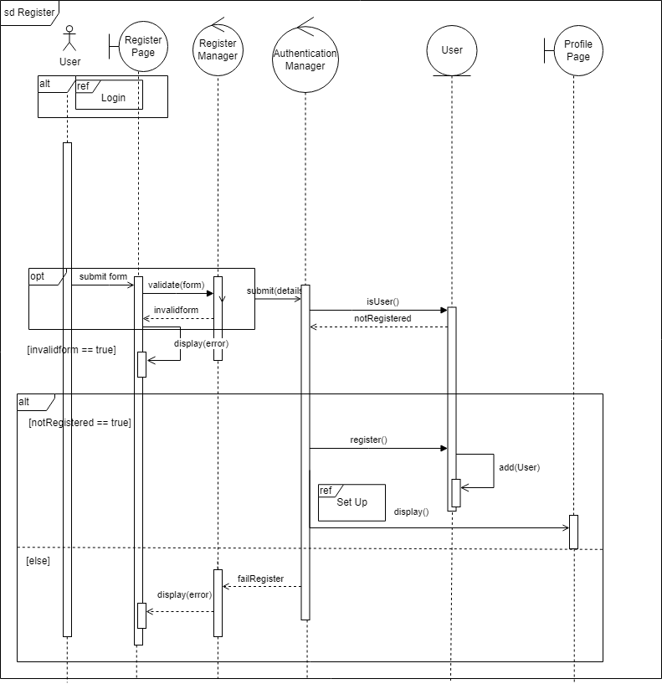

8.6.2 Set Up

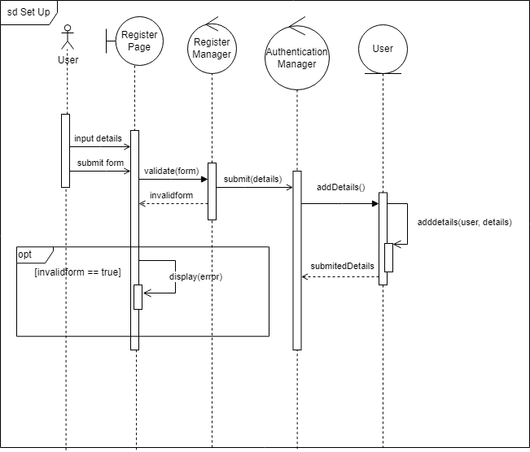

8.6.3 Login

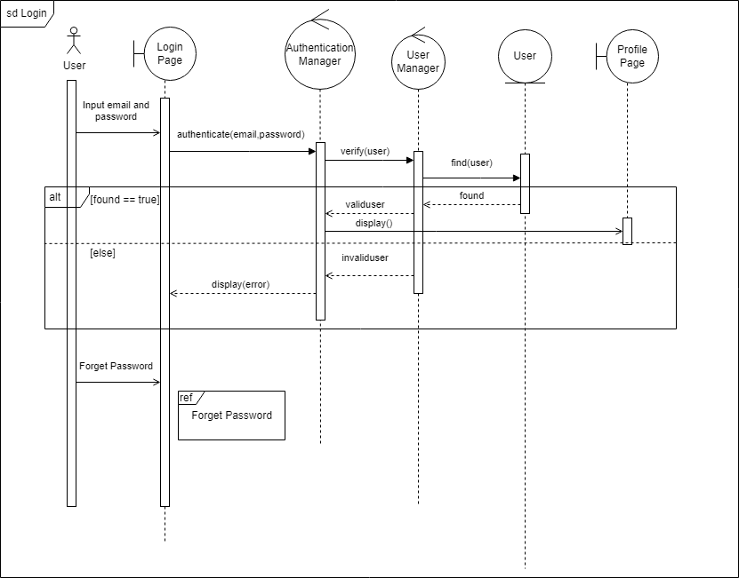

8.6.4 Forgot Password

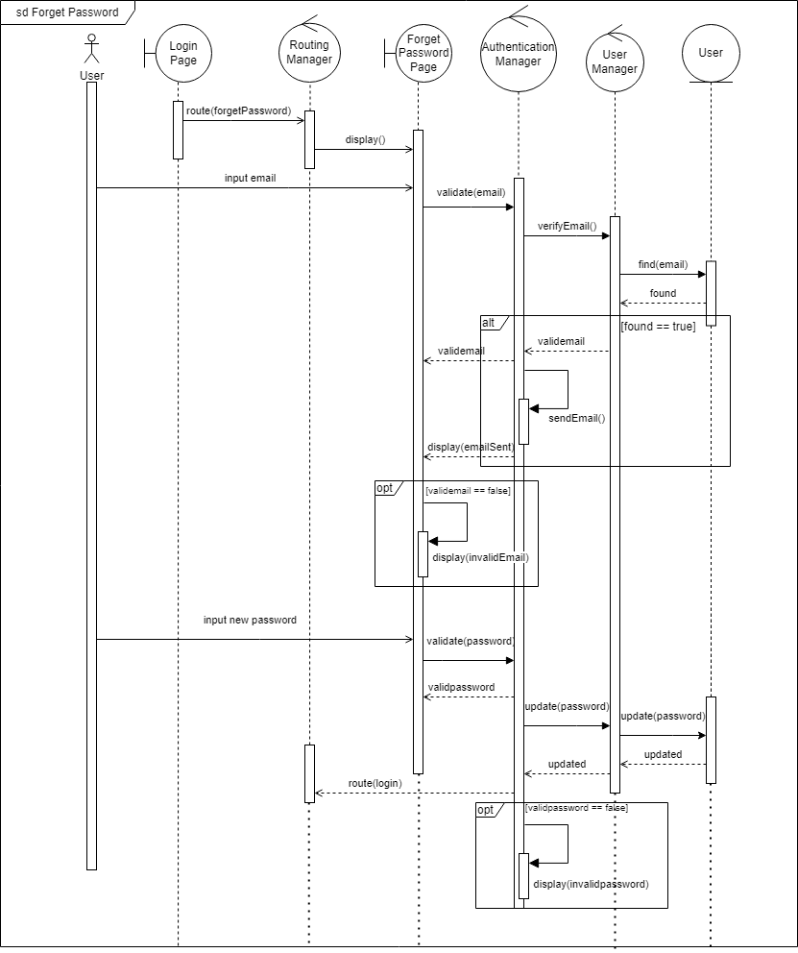

8.6.5 Locate Exercise Facilities

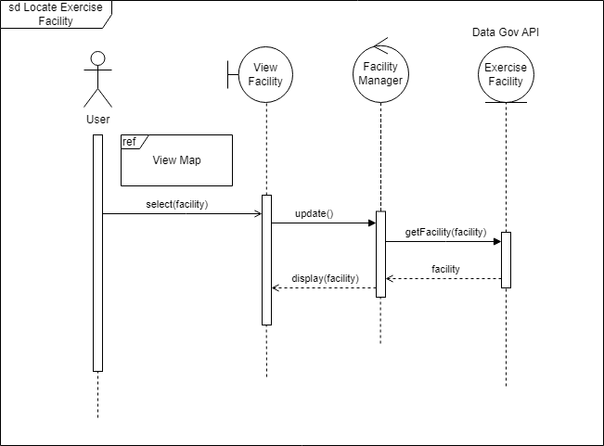

8.6.6 Locate Food Facilities

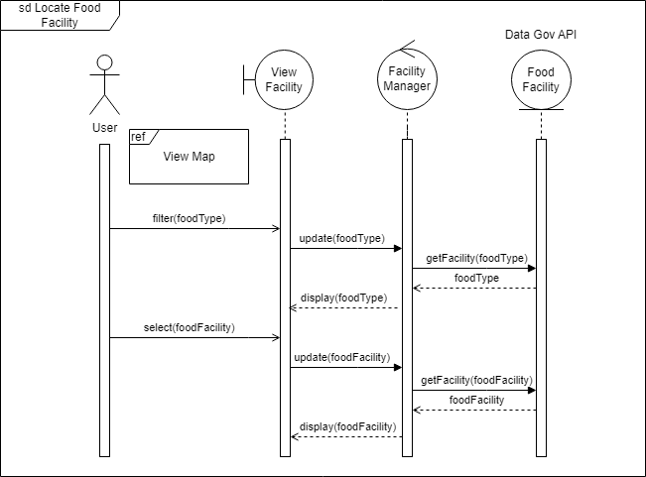

8.6.7 View Map

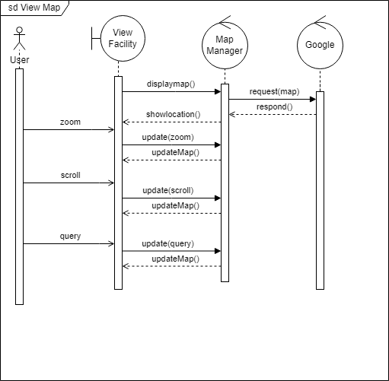

8.6.8 View Exercise

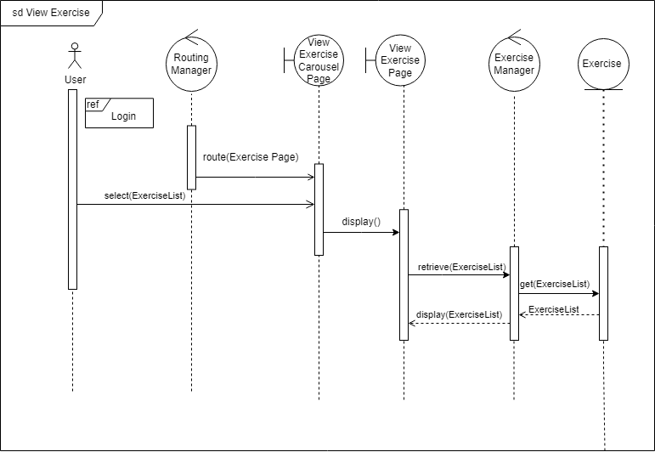

8.6.9 Manage Exercise Plan

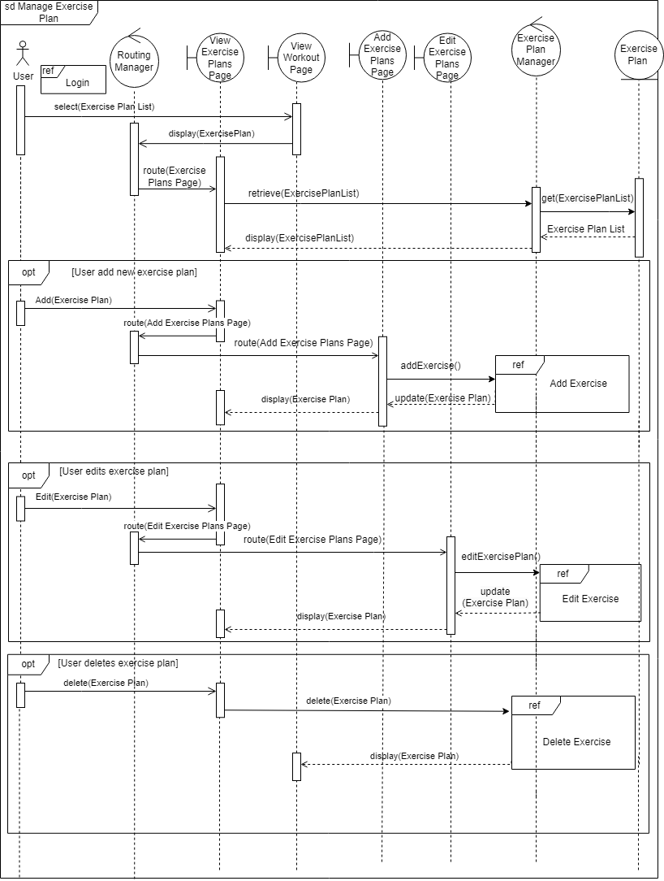

8.6.10 Add Exercise

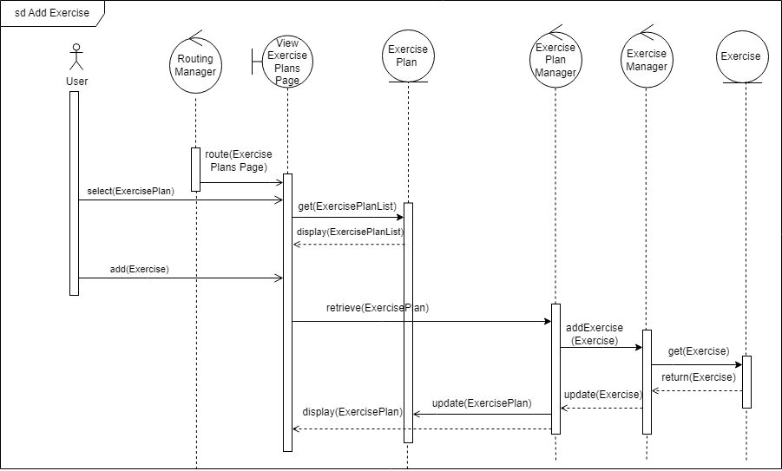

8.6.11 Edit Exercise

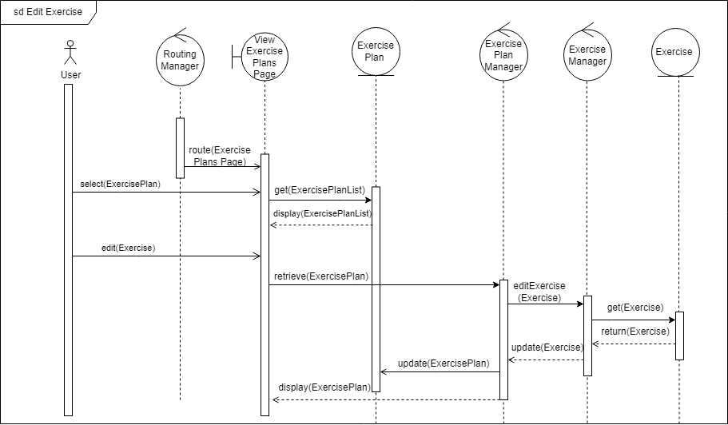

8.6.12 Delete Exercise

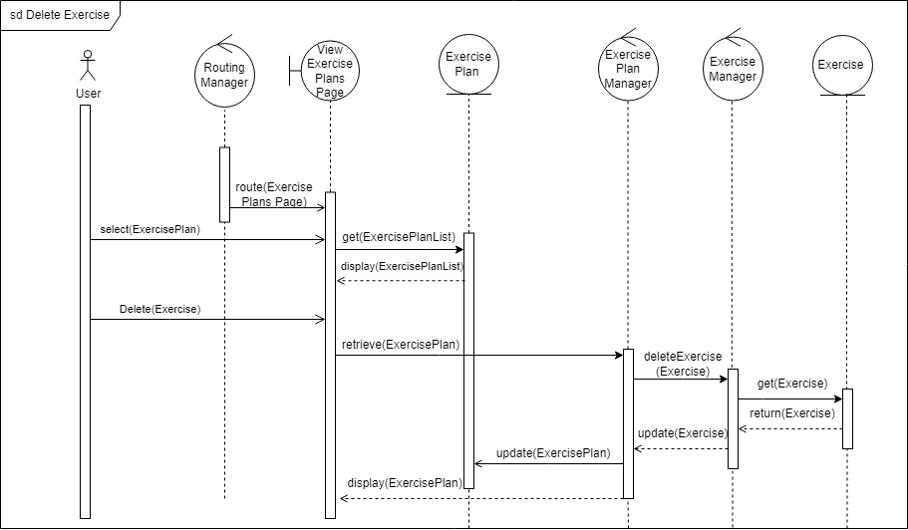

8.6.13 Manage Review

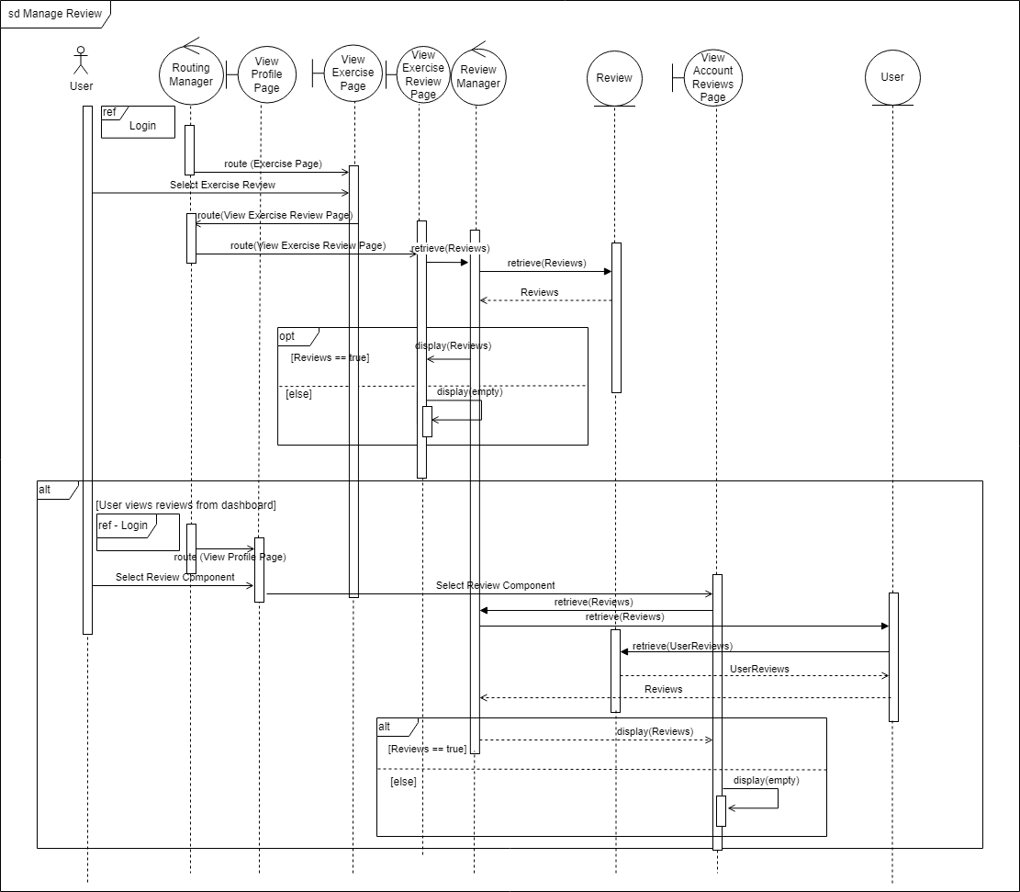

8.6.14 Add Review

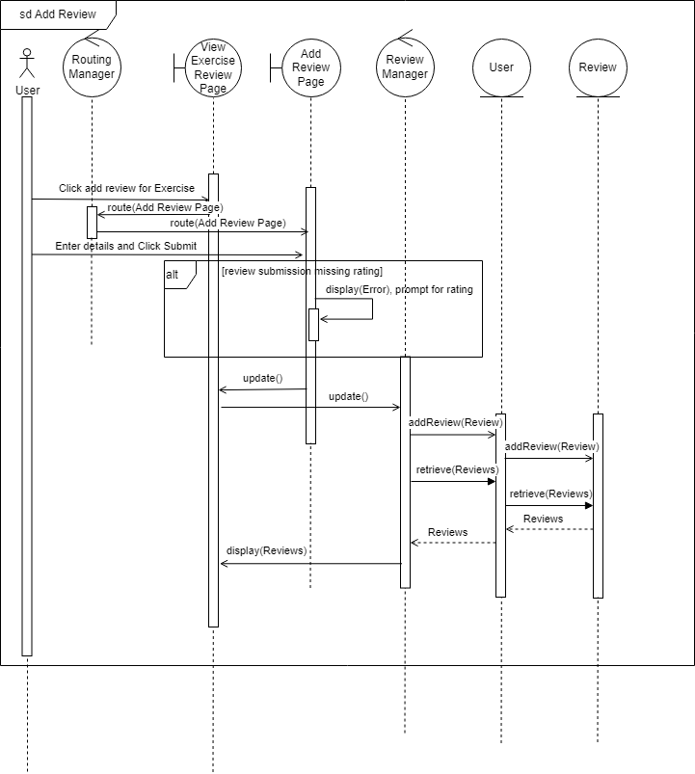

8.6.15 Delete Review

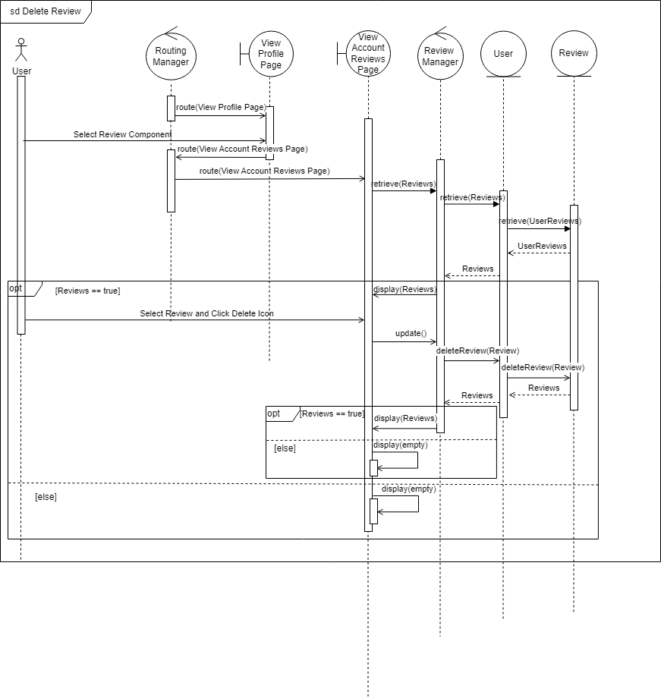

8.6.16 Schedule Exercise

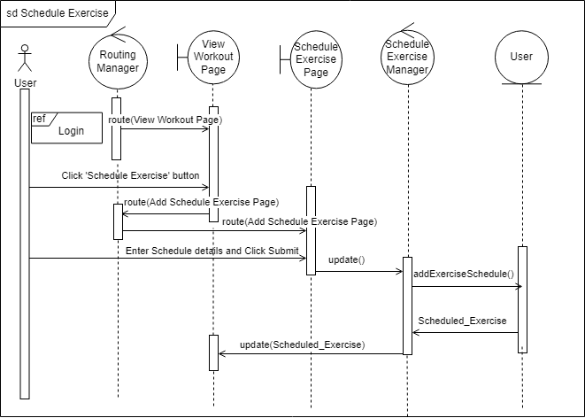

8.6.17 View Schedule Exercise

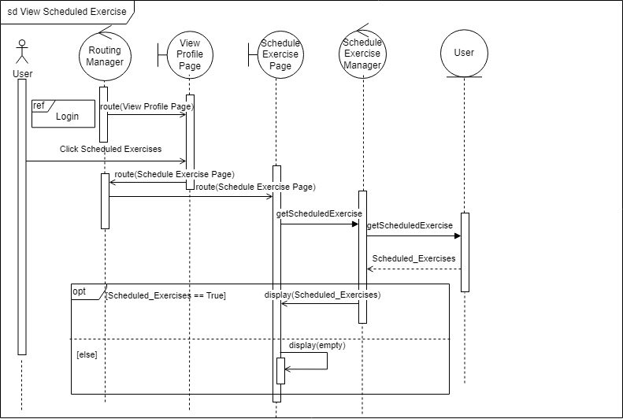

8.6.18 View Profile

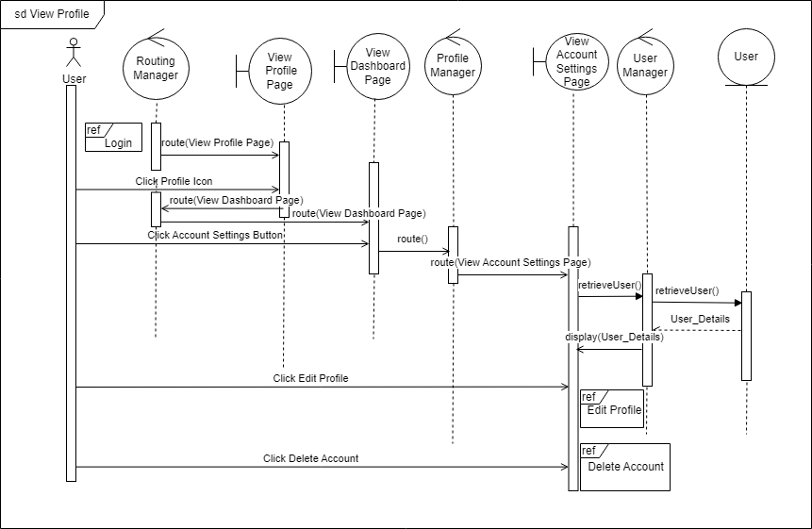

8.6.19 Edit Profile

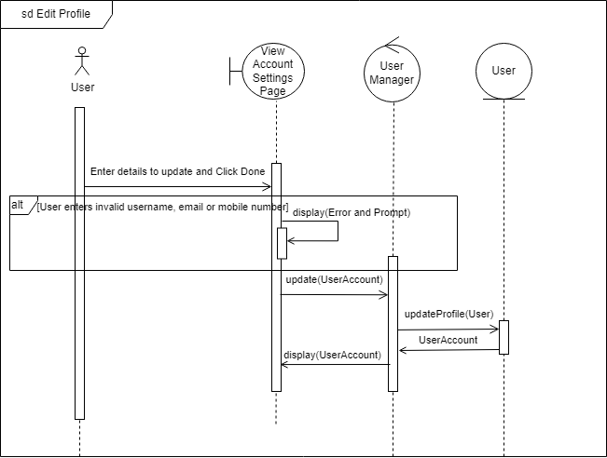

8.6.20 Delete Account

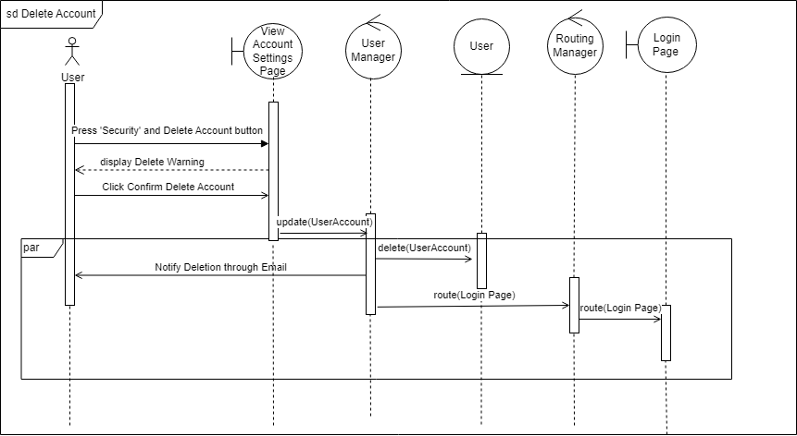

8.6.21 Manage Fitness Goals

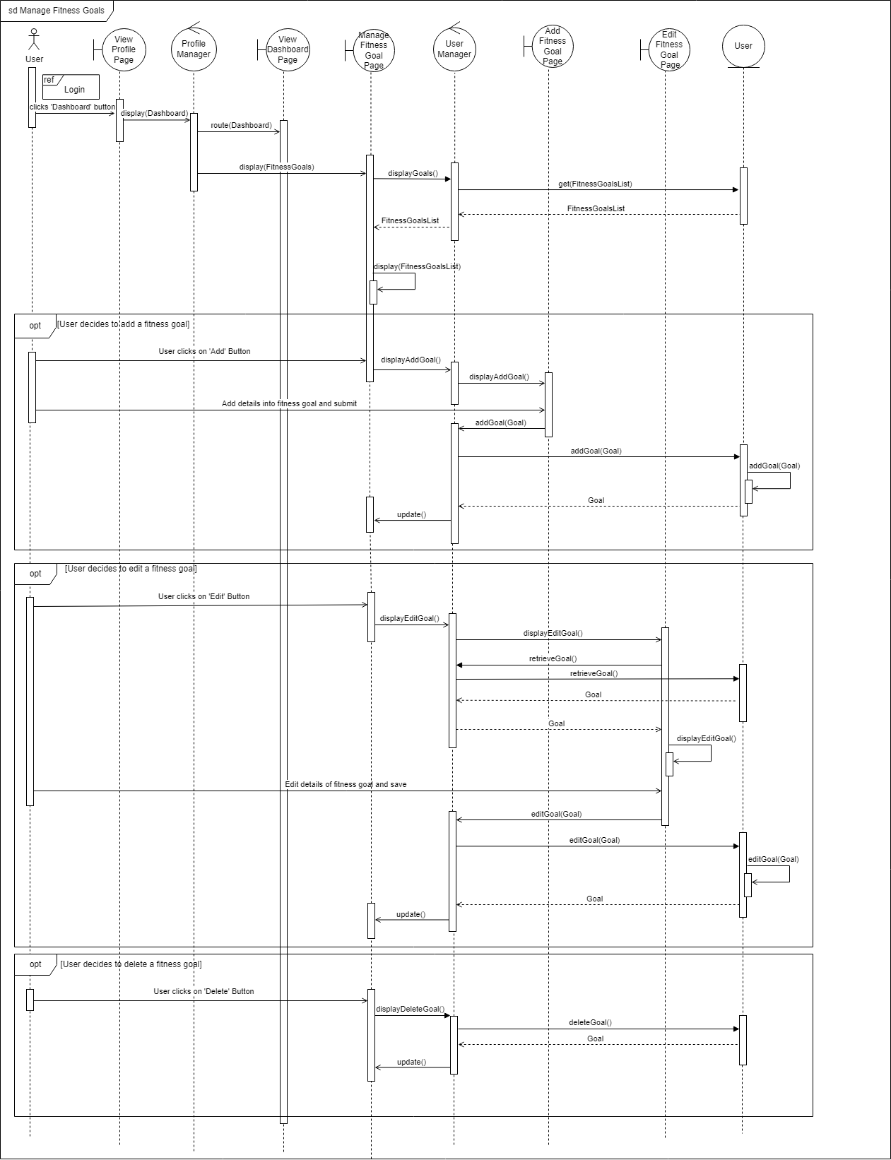

8.6.22 Calculate BMI

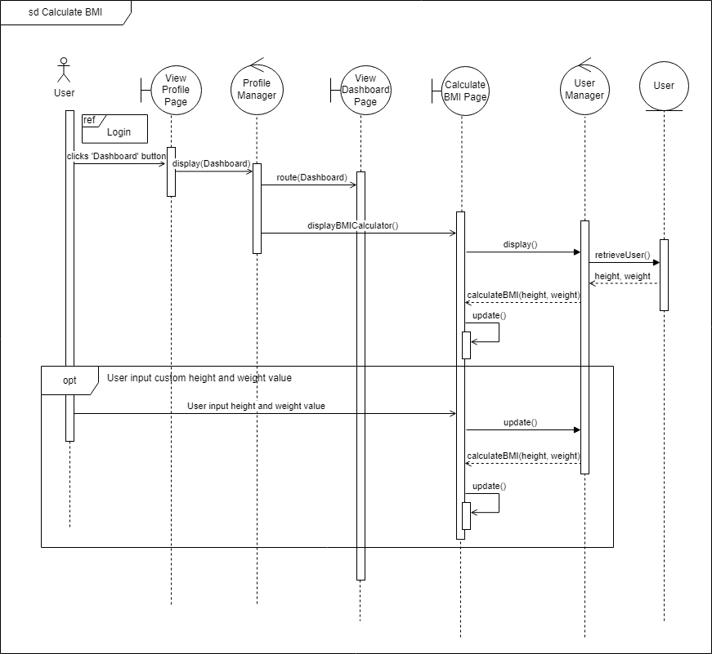

8.6.23 View Calories History

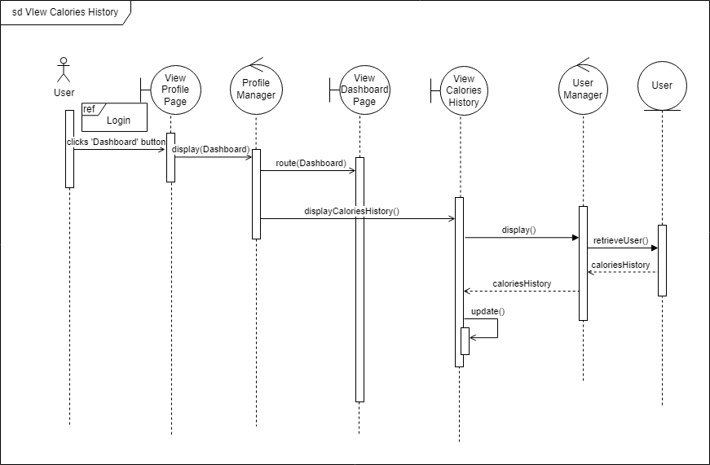

8.6.24 View Daily Calories

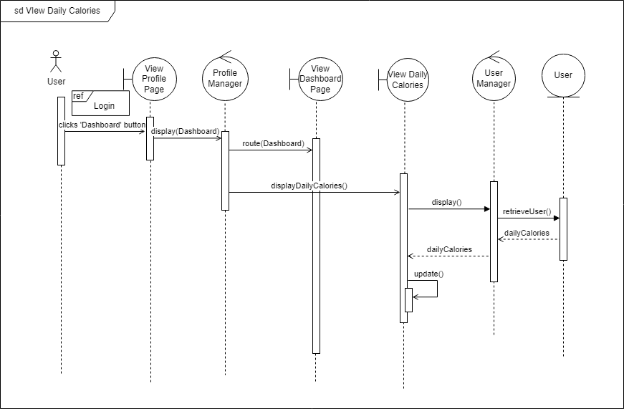

## 8.7 Unit Testing

### 8.7.1 Black Box Testing

For Black Box Testing we used both equivalence class testing and boundary value testing for the registering and setting up of users.

1. Register and Set Up User

Equivalence Classes and Boundary Values

**Username**

| **Specification** | No spacing  Minimum 6 characters long  Must not be null |
| --- | --- |
| **Valid Equivalence Classes** | edmund562 |
| **Invalid Equivalence Classes** | edmun (5 characters)  edmund 562 (spacing |

**Name**

| **Specification** | Must not be null |
| --- | --- |
| **Valid Equivalence Classes** | Ernest |
| **Invalid Equivalence Classes** | Null input |

**Email Address**

| **Specification** | Requires ‘@’ in email  Requires ‘.com’ in email  Cannot have been used  Cannot be null |
| --- | --- |
| **Valid Equivalence Classes** | user@gmail.com |
| **Invalid Equivalence Classes** | usergmail.com (No @ symbol),  user@gmail (No .com)  [user@gmail.com](mailto:user@gmail.com) (used email) |

**Password**

| **Specification** | Minimum 8 characters  One uppercase  One special characters  One lowercase  One numeric character  Must not be null |
| --- | --- |
| **Valid Equivalence Classes** | P@ssw0rd |
| **Invalid Equivalence Classes** | Null input  P@ssw0r (7 characters)  p@ssw0rd (No uppercase)  Passw0rd (No special case)  P@ssword (No numeric)  P@SSW0RD (No lowercase) |

**Re-enter Password**

| **Specification** | Same input as password  Must not be null |
| --- | --- |
| **Valid Equivalence Classes** | Same input as password |
| **Invalid Equivalence Classes** | Null input  Different input from password |

**Date of Birth**

| **Specification** | Cannot be less than born 10 years ago (As of the current year)  Cannot be more than 100 years ago  Must not be null |
| --- | --- |
| **Valid Equivalence Classes** | 01 Jan 1923  3 Apr 2013 |
| **Invalid Equivalence Classes** | 31 Dec 1899  4 April 2014  Null input |

**Height**

| **Specification** | No negative numbers  Minimum of 90 cm  Maximum of 220 cm  Must not be null |
| --- | --- |
| **Valid Equivalence Classes** | 90, 220 |
| **Invalid Equivalence Classes** | -20  89.9  220.1 |

**Weight**

| **Specification** | No negative numbers  Minimum of 20 kg  Maximum of 400 kg  Must not be null |
| --- | --- |
| **Valid Equivalence Classes** | 20  400 |
| **Invalid Equivalence Classes** | -1  19.9  400.9 |

**Gender**

| **Specification** | Form control - only 3 acceptable values  Male, Female, Others |
| --- | --- |
| **Valid Equivalence Classes** | Male  Female  Others |
| **Invalid Equivalence Classes** |  |

**Phone Number**

| **Specification** | Phone number must be 8 digits  Number must begin with 6, 8 or 9  Must not be null |
| --- | --- |
| **Valid Equivalence Classes** | 61234567  80001234  91234000 |
| **Invalid Equivalence Classes** | 9234  78911234  Null input |

**Profile Picture**

| **Specification** | File must be a picture format  Allow for empty profile page which will use the default picture |
| --- | --- |
| **Valid Equivalence Classes** | Empty file  .jpg file  .png file  .gif file |
| **Invalid Equivalence Classes** | .txt file |

| **Username** | **Name** | **Email Address** | **Password** | **Re-enter**  **Password** | **Date of Birth** | **Height** | **Weight** | **Gender** | **Phone Number** | **Profile Picture** | **Expected Result** | **Test Result** |
| --- | --- | --- | --- | --- | --- | --- | --- | --- | --- | --- | --- | --- |
| edmund562 | Ernest | user@gmail.com | P@ssw0rd | P@ssw0rd | 3 April 2013 | 90 | 20 | Male | 80001234 | empty file | Account created | Account created |
| edmun | Ernest | edmund@gmail.com | P@ssw0rd | Password@123 | 4 Sep 1968 | 100 | 20.1 | Female | 80001234 | jpg file | Username is too short - a minimum of 6 characters. | Username is too short - a minimum of 6 characters. |
| edmund 562 | Ernest | edmund@gmail.com | P@ssw0rd | P@ssw0rd | 14 Apr 2000 | 110 | 21 | Others | 80001234 | png file | Username must not contain spaces | Username must not contain spaces |
| Null input | Ernest | edmund@gmail.com | P@ssw0rd | P@ssw0rd | 10 Feb 2001 | 120 | 200 | Male | 61234567 | empty file | No username provided! | No username provided! |
| ernestiscute | Null input | edmund@gmail.com | P@ssw0rd | P@ssw0rd | 19 Sep 1989 | 130 | 100 | Female | 61234567 | jpg file | No name provided! | No name provided! |
| solo588 | Ernest | usergmail.com | P@ssw0rd | P@ssw0rd | 21 Jan 2002 | 140 | 50.5 | Others | 61234567 | png file | Invalid email address | Invalid email address |
| blackknight | Ernest | user@gmail | P@ssw0rd | P@ssw0rd | 1 Dec 1938 | 150 | 60 | Male | 61234567 | empty file | Invalid email address | Invalid email address |
| yellowriver | Ernest | Null input | P@ssw0rd | P@ssw0rd | 31 Jan 1948 | 160 | 70 | Female | 61234567 | jpg file | No password provided! | No password provided! |
| yellowriver | Ernest | user@gmail.com | P@ssw0rd | P@ssw0rd | 31 Jan 1948 | 160 | 70 | Female | 61234567 | jpg file | Email has been used. Please register with another email or login with existing account. | Email has been used. Please register with another email or login with existing account. |
| yell0wpanther | Ernest | edmund@gmai.com | Null input | P@ssw0rd | 10 Aug 1900 | 170 | 80 | Others | 61234567 | png file | No password provided! | No password provided! |
| cptUSA | Ernest | edmund@gmail.com | P@ssw0r | P@ssw0r | 8 Aug 1950 | 180 | 90.6 | Male | 61234567 | empty file | Password is too short - a minimum of 8 characters. | Password is too short - a minimum of 8 characters. |
| KJisCool | Ernest | edmund@gmail.com | p@ssw0rd | p@ssw0rd | 6 Jun 1948 | 190 | 100.6 | Female | 91234000 | jpg file | Password must contain at least one Uppercase, Lowercase, one number and special character | Password must contain at least one Uppercase, Lowercase, one number and special character |
| ThomasTrain | Ernest | edmund@gmail.com | Passw0rd | Passw0rd | 15 Nov 1967 | 200 | 110.1 | Others | 91234000 | png file | Password must contain at least one Uppercase, Lowercase, one number and special character | Password must contain at least one Uppercase, Lowercase, one number and special character |
| WhinnyBear | Ernest | edmund@gmail.com | P@ssword | P@ssword | 2 Aug 2000 | 210 | 120 | Male | 91234000 | empty file | Password must contain at least one Uppercase, Lowercase, one number and special character | Password must contain at least one Uppercase, Lowercase, one number and special character |
| HelloThere | Ernest | edmund@gmail.com | P@SSW0RD | P@SSW0RD | 5 May 2000 | 215 | 330.4 | Female | 91234000 | jpg file | Password must contain at least one Uppercase, Lowercase, one number and special character | Password must contain at least one Uppercase, Lowercase, one number and special character |
| JackTrades | Ernest | edmund@gmail.com | P@ssw0rd | p@ssw0rd | 3 Feb 1984 | 216.5 | 140.9 | Others | 91234000 | png file | Passwords must match | Passwords must match |
| JackTrades | Ernest | edmund@gmail.com | P@ssw0rd | Null input | 3 Feb 1984 | 216.5 | 140.9 | Others | 91234000 | png file | No password provided! | No password provided! |
| BlueBalls | Ernest | edmund@gmail.com | P@ssw0rd | P@ssw0rd | 31 Dec 1899 | 115 | 150 | Male | 91234000 | empty file | You cannot choose a date before this! | You cannot choose a date before this! |
| BlueWaffle | Ernest | edmund@gmail.com | P@ssw0rd | P@ssw0rd | 4 April 2014 | 195 | 160 | Female | 91234000 | jpg file | You cannot be younger than 10 years old! | You cannot be younger than 10 years old! |
| BlueWaffle | Ernest | edmund@gmail.com | P@ssw0rd | P@ssw0rd | Null input | 195 | 160 | Female | 91234000 | jpg file | Please enter your date of birth | Please enter your date of birth |
| BlueBird | Ernest | edmund@gmail.com | P@ssw0rd | P@ssw0rd | 9 Mar 2009 | -20 | 170 | Others | 91234000 | png file | Must be at least 90cm | Must be at least 90cm |
| BlueBird | Ernest | edmund@gmail.com | P@ssw0rd | P@ssw0rd | 7 Oct 1995 | 89.9 | 180 | Male | 91234000 | empty file | Must be at least 90cm | Must be at least 90cm |
| BlueBird | Ernest | edmund@gmail.com | P@ssw0rd | P@ssw0rd | 7 Jul 1974 | 220.1 | 190.1 | Female | 91234000 | jpg file | Cannot be more than 220 cm | Cannot be more than 220 cm |
| BlueBird | Ernest | edmund@gmail.com | P@ssw0rd | P@ssw0rd | 7 Jul 1974 | Null input | 190.1 | Female | 91234000 | jpg file | Please enter your height in cm | Please enter your height in cm |
| BlueBird | Ernest | edmund@gmail.com | P@ssw0rd | P@ssw0rd | 1 Dec 1957 | 201 | 19.9 | Others | 91234000 | png file | Must be at least 20 kg | Must be at least 20 kg |
| BlueBird | Ernest | edmund@gmail.com | P@ssw0rd | P@ssw0rd | 29 Jan 1978 | 141 | -1 | Male | 91234000 | Empty file | Must be at least 20 kg | Must be at least 20 kg |
| BlueBird | Ernest | edmund@gmail.com | P@ssw0rd | P@ssw0rd | 29 Jan 1978 | 185.6 | 400.9 | Female | 91234000 | jpg file | Cannot be more than 400 kg | Cannot be more than 400 kg |
| BlueBird | Ernest | edmund@gmail.com | P@ssw0rd | P@ssw0rd | 29 Jan 1978 | 185.6 | Null input | Female | 91234000 | jpg file | Please enter your weight in kg | Please enter your weight in kg |
| BlueBird | Ernest | edmund@gmail.com | P@ssw0rd | P@ssw0rd | 29 Jan 1978 | 180 | 80 | Female | 9234 | jpg file | Phone number is not valid | Phone number is not valid |
| BlueBird | Ernest | edmund@gmail.com | P@ssw0rd | P@ssw0rd | 29 Jan 1978 | 180 | 80 | Female | 78911234 | jpg file | Phone number is not valid | Phone number is not valid |
| BlueBird | Ernest | edmund@gmail.com | P@ssw0rd | P@ssw0rd | 29 Jan 1978 | 180 | 80 | Female | Null input | jpg file | Please enter your mobile number | Please enter your mobile number |
| BlueBird | Ernest | edmund@gmail.com | P@ssw0rd | P@ssw0rd | 29 Jan 1978 | 190 | 220 | Others | 91234000 | txt file | An error have occurred. Please follow the direction Only accept image files with extension of GIF, JPG, PNG | An error have occurred. Please follow the direction Only accept image files with extension of GIF, JPG, PNG |

### 8.7.2 White Box Testing

For White Box Testing we use basic path testing for two test cases: Adding Fitness Goals and Registering Users.

1. Adding Fitness Goals

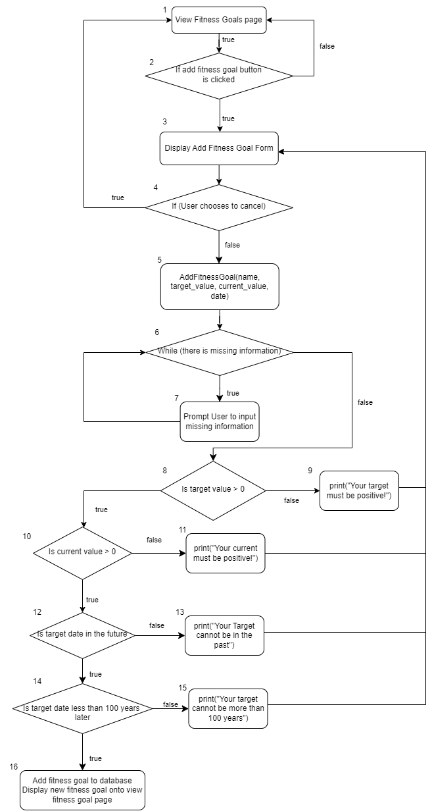

$Cyclomatic Complexity = |edges| - |nodes| + 2= 22 -16 +2 = 8$

$Cyclomatic Complexity = |decision point| + 1 = 7+ 1 = 8$

**Basic Paths**

Path 1 (baseline): 1, 2, 3, 4, 5, 6, 8, 10, 12, 14, 16

Path 2: 1, 2, 1

Path 3: 1, 2, 3, 4, 1

Path 4: 1, 2, 3, 4, 5, 6, 7, 6, 8, 10, 12, 14, 16

Path 5: 1, 2, 3, 4, 5, 6, 8, 9, 3, 4, 5, 6, 8, 10, 12, 14, 16

Path 6: 1, 2, 3, 4, 5, 6, 8, 10, 11, 3, 4, 5, 6, 8, 10, 12, 14, 16

Path 7: 1, 2, 3, 4, 5, 6, 8, 10, 12, 13, 3, 4, 5, 6, 8, 10, 12, 14, 16

Path 8: 1, 2, 3, 4, 5, 6, 8, 10, 12, 14, 15, 3, 4, 5, 6, 8, 10, 12, 14, 16

**Test Cases**

| **Path** | **Clicked** | **Cancel** | **Missing Information** | **Target Value** | **Current Value** | **Target Date** | **Expected Result** | **Test Result** |
| --- | --- | --- | --- | --- | --- | --- | --- | --- |
| 1 | True | False | False | 30 | 20 | 3 Aug 2023 | Fitness Goal Created | Fitness Goal Created |
| 2 | False | False | - | - | - | - | Redirected to Fitness Goal Page | Redirected to Fitness Goal Page |
| 3 | True | True | - | - | - | - | Redirected to Fitness Goal Page | Redirected to Fitness Goal Page |
| 4 | True | False | True | 30 | NULL | 3 Aug 2023 | You must have a current value! | You must have a current value! |
| 5 | True | False | False | -1 | 20 | 3 Aug 2023 | Your target must be positive | Your target must be positive |
| 6 | True | False | False | 30 | -1 | 3 Aug 2023 | Your current must be positive! | Your current must be positive! |
| 7 | True | False | False | 30 | 20 | 3 Aug 2023 | Your Target cannot be in the past | Your Target cannot be in the past |
| 8 | True | False | False | 30 | 20 | 3 Aug 2223 | Your target cannot be more than 100 years | Your target cannot be more than 100 years |

### 

1. Register users

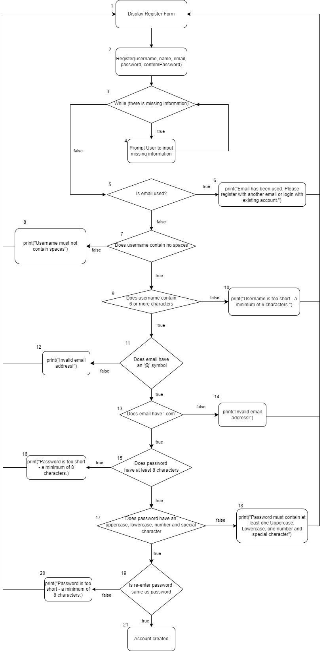

$Cyclomatic Complexity = |edges| - |nodes| + 2= 29 -21 +2 = 10$

$Cyclomatic Complexity = |decision point| + 1 = 9+ 1 = 10$

**Basic Paths**

Path 1 (baseline): 1, 2, 3, 5, 7, 9, 11, 13, 15, 17, 19, 21

Path 2: 1, 2, 3, 4, 3, 5, 7, 9, 11, 13, 15, 17, 19, 21

Path 3: 1, 2, 3, 5, 6, 1, 2, 3, 5, 7, 9, 11, 13, 15, 17, 19, 21

Path 4: 1, 2, 3, 5, 7, 8, 1, 2, 3, 5, 7, 9, 11, 13, 15, 17, 19, 21

Path 5: 1, 2, 3, 5, 7, 9, 10, 1, 2, 3, 5, 7, 9, 11, 13, 15, 17, 19, 21

Path 6: 1, 2, 3, 5, 7, 9, 11, 12, 1, 2, 3, 5, 7, 9, 11, 13, 15, 17, 19, 21

Path 7: 1, 2, 3, 5, 7, 9, 11, 13, 14, 1, 2, 3, 5, 7, 9, 11, 13, 15, 17, 19, 21

Path 8: 1, 2, 3, 5, 7, 9, 11, 13, 15, 16, 1, 2, 3, 5, 7, 9, 11, 13, 15, 17, 19, 21

Path 9: 1, 2, 3, 5, 7, 9, 11, 13, 15, 17, 18, 1, 2, 3, 5, 7, 9, 11, 13, 15, 17, 19, 21

Path 10: 1, 2, 3, 5, 7, 9, 11, 13, 15, 17, 19, 20, 1, 2, 3, 5, 7, 9, 11, 13, 15, 17, 19, 21

**Test Cases**

| **Path** | **Username** | **Name** | **Email** | **Password** | **Re-enter password** | **Date of Birth** | **Expected Result** | **Test Result** |
| --- | --- | --- | --- | --- | --- | --- | --- | --- |
| 1 | edmund562 | Ernest | user@gmail.com | P@ssw0rd | P@ssw0rd | 3 April 2013 | Account Created | Account Created |
| 2 | edmund562 | Null input | user@abc.com | P@ssw0rd | P@ssw0rd | 3 April 2013 | No name provided! | No name provided! |
| 3 | edmund562 | Ernest | user@gmail.com | P@ssw0rd | P@ssw0rd | 3 April 2013 | Email has been used. Please register with another email or login with existing account. | Email has been used. Please register with another email or login with existing account. |
| 4 | edmund 562 | Ernest | user@abc.com | P@ssw0rd | P@ssw0rd | 3 April 2013 | Username must not contain spaces | Username must not contain spaces |
| 5 | edmun | Ernest | user@abc.com | P@ssw0rd | P@ssw0rd | 3 April 2013 | Username is too short - a minimum of 6 characters. | Username is too short - a minimum of 6 characters. |
| 6 | edmund562 | Ernest | usergmail.com | P@ssw0rd | P@ssw0rd | 3 April 2013 | Invalid email address | Invalid email address |
| 7 | edmund562 | Ernest | user@abc | P@ssw0rd | P@ssw0rd | 3 April 2013 | Invalid email address | Invalid email address |
| 8 | edmund562 | Ernest | user@abc.com | P@ssw0r | P@ssw0r | 3 April 2013 | Password is too short - a minimum of 8 characters. | Password is too short - a minimum of 8 characters. |
| 9 | edmund562 | Ernest | user@abc.com | password | P@ssw0r | 3 April 2013 | Password must contain at least one Uppercase, Lowercase, one number and special character | Password must contain at least one Uppercase, Lowercase, one number and special character |
| 10 | edmund562 | Ernest | user@abc.com | P@ssw0rd | Passw0rd | 3 April 2013 | Passwords must match | Passwords must match |